SSUET/QR/112

Laboratory Manual
Computer Networking Lab
5th Semester Fall 2024



Instructor Copy

BS in Computer Science
Department of Computer Science & Information Technology
Sir Syed University of Engineering and Technology
University Road Karachi - 75300
http://www.ssuet.edu.pk

Course Learning Outcome(s):
No. | Course Learning Outcomes (CLOs) | Program Learning Outcomes (PLOs) | Bloom’s Taxonomy

Laboratory Experiments
Lab # | Objectives | Page No.
1
2
3
4
5
6
7
8
9
10
11
12
13
14

Laboratory Rubrics
Criteria | Exceeds Expectations (>=90%) | Meets Expectations (70%-89%) | Developing  (50%-69%) | Unsatisfactory (<50%)
Software Handling  (2) | Able to use software with its standard and advanced features without assistance | Able to use software with its standard and advanced features with minimal assistance | Able to use software with its standard features with assistance | Unable to use the software
Programming/ Simulation  (5) | Able to program/ simulate the lab tasks with simplification | Able to program/ simulate the lab tasks without errors | Able to program/ simulate lab tasks with errors | Unable to program/simulate
Results  (2) | Able to achieve all the desired results with alternate ways to improve measurements | Able to achieve all the desired results | Able to achieve most of the desired results with errors | Unable to achieve the desired results
Lab Report  (1) | Laboratory manual has no grammatical and/ or spelling errors.  All sections of the report are very well written and technically accurate. | Laboratory manual has very few grammatical/ spelling errors.  All sections of the report are technically accurate. | -Laboratory manual has multiple grammatical/ spelling errors.  Few sections of the report contain technical error s. | Laboratory manual has several grammatical/ spelling errors and sentence construction is poor.  -All sections of the report contain multiple technical errors.

Laboratory Score
Lab# | Criteria |  |  |  | Score
 | Software Handling  ( )/2 | Programming/ Simulations ( )/5 | Results  ( )/2 | Lab Report  ( )/1
 | Software Handling  ( )/2 | Programming/ Simulations ( )/5 | Results  ( )/2 | Lab Report  ( )/1
 | Software Handling  ( )/2 | Programming/ Simulations ( )/5 | Results  ( )/2 | Lab Report  ( )/1
 | Software Handling  ( )/2 | Programming/ Simulations ( )/5 | Results  ( )/2 | Lab Report  ( )/1
 | Software Handling  ( )/2 | Programming/ Simulations ( )/5 | Results  ( )/2 | Lab Report  ( )/1
 | Software Handling  ( )/2 | Programming/ Simulations ( )/5 | Results  ( )/2 | Lab Report  ( )/1
 | Software Handling  ( )/2 | Programming/ Simulations ( )/5 | Results  ( )/2 | Lab Report  ( )/1
 | Software Handling  ( )/2 | Programming/ Simulations ( )/5 | Results  ( )/2 | Lab Report  ( )/1
 | Software Handling  ( )/2 | Programming/ Simulations ( )/5 | Results  ( )/2 | Lab Report  ( )/1
 | Software Handling  ( )/2 | Programming/ Simulations ( )/5 | Results  ( )/2 | Lab Report  ( )/1
 | Software Handling  ( )/2 | Programming/ Simulations ( )/5 | Results  ( )/2 | Lab Report  ( )/1
 | Software Handling  ( )/2 | Programming/ Simulations ( )/5 | Results  ( )/2 | Lab Report  ( )/1
 | Software Handling  ( )/2 | Programming/ Simulations ( )/5 | Results  ( )/2 | Lab Report  ( )/1
 | Software Handling  ( )/2 | Programming/ Simulations ( )/5 | Results  ( )/2 | Lab Report  ( )/1
Obtained Score out of (140)
Obtained Score out of (X) = Obtained Score out of (140) /140* X

Semester Project Rubric
Criteria | Exceeds Expectations (>=90%) | Meets Expectations (70%-89%) | Developing  (50%-69%) | Unsatisfactory (<50%) | Score
Project Demonstration  (5) | Able to demonstrate the project with achievement of required objectives having clear understanding of project limitations and future enhancements. Hardware and/or Software modules are fully functional, if applicable. | Able to demonstrate the project with achievement of required objectives but understanding of project limitations and future enhancements is insufficient. Hardware and/or Software modules are functional, if applicable. | Able to demonstrate the project with achievement of a*t least 50% required objectives and insufficient understanding of project limitations and future enhancements. Hardware and/or Software modules are partially functional, if applicable. | Able to demonstrate the project with achievement of less than 50% required objectives and lacks in understanding of project limitations and future enhancements. Hardware and/or Software modules are not functional, if applicable.
Project results  (3) | Able to achieve all the desired results with alternate ways to improve measurements | Able to achieve all the desired results | Able to achieve most of the desired results with errors | Unable to achieve the desired results
Report Writing  (3) | Project report has no grammatical and/ or spelling errors.  All sections of the report are very well-written and technically accurate. | Project report has very few grammatical/ spelling errors.  All sections of the report are technically accurate. | Project report has multiple grammatical/ spelling errors.  Few sections of the report contain technical errors. | Project report has several grammatical/ spelling errors and sentence construction is poor.
Viva  (4) | Able to answer the questions easily and correctly across the project. | Able to answer the questions related to the project | Able to answer the questions but with mistakes | Unable to answer the questions
Obtained Score out of (15)
Obtained Score out of (X)= Obtained Score out of (15) /15* X

Laboratory Examination Rubric
Criteria | Exceeds Expectations (>=90%) | Meets Expectations (70%-89%) | Developing  (50%-69%) | Unsatisfactory (<50%) | Score
Performance  (15) | Able to present full knowledge of both problem and solution. | Able to present adequate knowledge of both problem and solution | Able to present sufficient knowledge of both problem and solution | No or very less knowledge of both problem and solution
Viva  (5) | Able to answer the questions easily and correctly across the project. | Able to answer the questions related to the project | Able to answer the questions but with mistakes | Unable to answer the questions
Obtained Score out of (20)
Obtained Score out of (X)= Obtained Score out of (20) /20* X

Final Lab Assessment

Criteria | Score
Laboratory (15)
Semester Project (15)
Laboratory Examination (20)
Total Score out of (50)

Examiner: _______________________________
(Name and Signature)

Lab # 01 OBJECT

To Study about basics of :
- Data Communication
- Types of Networks

THEORY

Data Communication:

Data communications are the exchange of data between two devices via some form of physical medium (transmission medium) such as a wire cable. The word data refers to information presented in whatever form text representation (text, number, images, audio, video etc.).

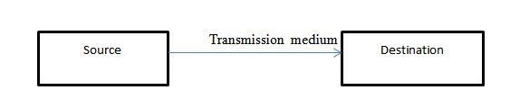

Data Communication Model:

The fundamental purpose of a data communications system is the exchange of data between two parties. This device generates the data to be transmitted; examples are telephones and personal computers.

Key Elements of the model:

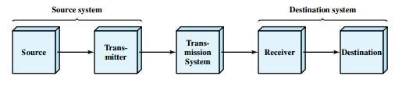

- Source. This device generates the data to be transmitted; examples are telephones and personal computers.

- Transmitter: Usually, the data generated by a source system are not transmitted directly in the form in which they were generated. Rather, a transmitter transforms and encodes the information in such a way as to produce electromagnetic signals that can be transmitted across some sort of transmission system. For example, a modem takes a digital bit stream from an attached device such as a personal computer and transforms that bit stream into an analog signal that can be handled by the telephone network.

- Transmission system: This can be a single transmission line or a complex network connecting source and destination.

- Receiver: The receiver accepts the signal from the transmission system and converts it into a form that can be handled by the destination device. For example, a modem will accept an analog signal coming from a network or transmission line and convert it into a digital bit stream.

- Destination: Takes the incoming data from the receiver.

Example :

Communication between a workstation (A node or stand-alone PC that is connected with network is called Workstation. A workstation is generally a client) and a server over a public telephone network.
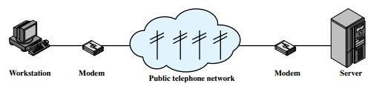

Computer Network:

A computer network is a set of computers connected together for the purpose of sharing resources.
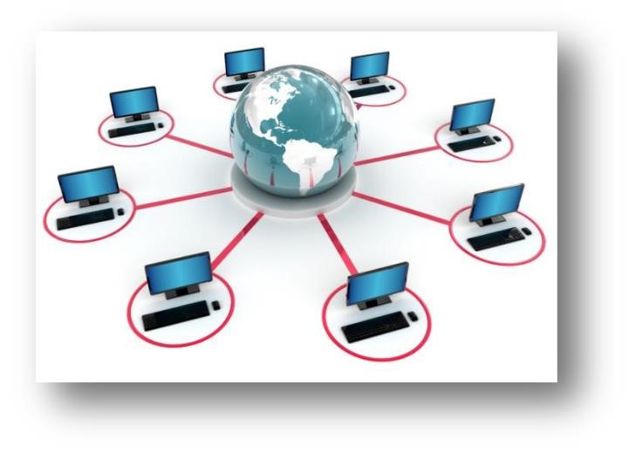

Computer Networking:

Computer networking is an engineering discipline that aims to study and analyze the communication process among various computing devices or computer systems that are linked, or networked, together to exchange information and share resources. Types of Network:
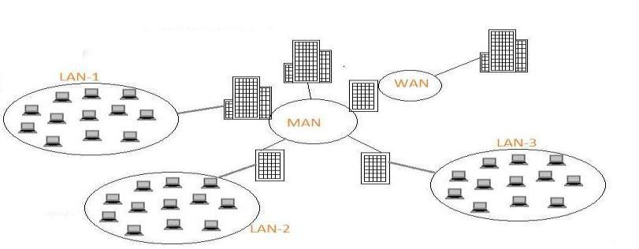

LAN

- LAN (Local Area Network) is a group of computers and other network devices which are connected together.

- All the devices that are part of LAN are within a building or multiple building. LAN network has very high speed.

WAN

- WAN (Wide Area Network) is a group of computers and other network devices which are connected together which is not restricted to a geographical location.
Internet is WAN
- All the devices that are part of WAN have no geographical boundaries.
- WAN speed varies based on geographical location of the servers. WAN connects several LANs

MAN

MAN ((Metropolitan Area Network) is a larger network of computers and other network devices which are connected together usually spans several buildings or large geographical area.All the devices that are part of MAN are span across buildings or small town

LAB TASK:

- Difference between network and networking?

__________________________________________________________________
__________________________________________________________________
__________________________________________________________________
__________________________________________________________________
__________________________________________________________________

- Components of data communication model?

__________________________________________________________________
__________________________________________________________________ __________________________________________________________________

- Does analogue conversation take place in source as transmitter?

__________________________________________________________________
__________________________________________________________________ __________________________________________________________________

( 4) Give an example of data communication model?

__________________________________________________________________
__________________________________________________________________
__________________________________________________________________ __________________________________________________________________

- What is Peer-to-Peer network?

__________________________________________________________________
__________________________________________________________________
__________________________________________________________________ __________________________________________________________________

- Build LAN & WAN environment using Packet Tracer?

Lab # 02 OBJECT

To Study about basics of:
* Network Topology and its Types

THEORY

Network Topology:

A network topology is a pattern in which nodes(e.g. printer, computer, router or other devices) are connected to a Local Area Network(LAN) or other networks via a links(erg twisted pair, copper wire cable or optical fiber cable).

Main Types of Network Topologies:

The following sections discuss the physical topologies used in networks and other related topics.

- Linear Bus
- Star Ring
- Mesh

Lin ear Bus:
.

Bus topology is a network type in where every computer and network device is connected to single cable.

In the bus network topology, every work station is connected to a main cable called the bus. Therefore, in effect, each workstation is directly connected to every other workstation in the network.

Advantages of Linear Bus Topology:






It is cost effective.
Cable required is least compared to other network topology. Used in small networks.
It is easy to understand.
Easy to expand joining two cables together.

Disadvantages of Linear Bus Topology:





Cables fails then whole network fails.
If network traffic is heavy or nodes are more the performance of the network decreases. Cable has a limited length. It is slower than the ring topology.

Star:
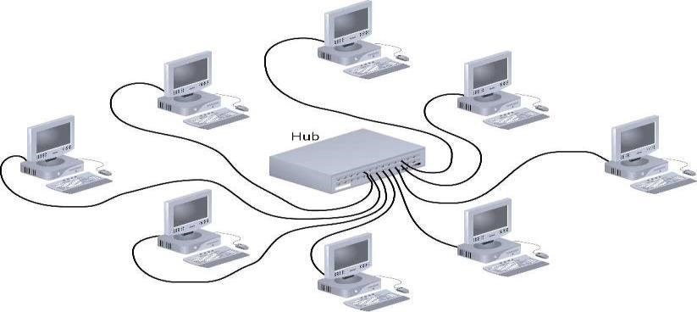

In this type of topology all the computers are connected to a single hub through a cable. This hub is the central node and all others nodes are connected to the central node.

Advantages of Star Topology:

- Fast performance with few nodes and low network traffic.
- Hub can be upgraded easily.
- Easy to troubleshoot.
- Easy to setup and modify.
- Only that node is affected which has failed rest of the nodes can work smoothly.

Disadvantages of Star Topology:

- Cost of installation is high.
- Expensive to use.

Ring:

It is called ring topology because it forms a ring as each computer is connected to another computer, with the last one connected to the first. Exactly two neighbors for each cable device.

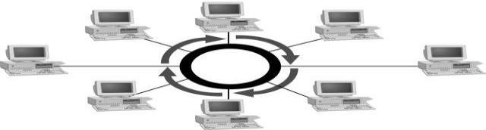

Advantages of Ring Topology:

- Transmitting network is not affected by high traffic or by adding more nodes, as only the nodes having tokens can transmit data.
- Cheap to install and expand.

Disadvantages of Ring Topology:




Troubleshooting is difficult in ring topology.
Adding or deleting the computers disturbs the network activity. Failure of one computer disturbs the whole network.

Mesh:

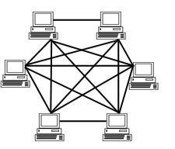

A network setup where each computer and network device is interconnected with one another.

There are two types of mesh topology network:

- Fully mesh network
- Partially mesh network

Advantages of Mesh Topology:

- each node is connected to several others; when a node fails its neighbors find other routes
- capacity can be added simply by adding nodes

Disadvantages of Mesh Topology:

- There are high chances of redundancy in many of the network connections.
- Expensive.
- Maintenance is difficult.

Considerations when choosing a Topology:

Money: A linear bus network may be the least expensive way to install a network; you do not have to purchase concentrators.

Length of cable needed: The linear bus network uses shorter lengths of cable.

Future growth: With a star topology, expanding a network is easily done by adding another concentrator.

Cable type: The most common cable in schools is unshielded twisted pair, which is most often used with star topologies.

LAB TASK:

- What is difference between partial and full mesh topology?

__________________________________________________________________
__________________________________________________________________
__________________________________________________________________
__________________________________________________________________
__________________________________________________________________

- Design Bus and Star Topology environment using Packet Tracer?

Lab #03(a)

Data Transmission

To Study about basics of data transmission media and its type.

THEORY:
Transmission Media

Transmission media that are used to convey information usually moves from one network device to another. The transmission medium is usually free space, metallic cable, or fiber-optic cable.
In telecommunications, transmission media can be divided into two broad categories: guided and unguided. Guided media include twisted-pair cable, coaxial cable, and fiber-optic cable. Unguided medium is free space i.e. wireless trans-mission occurs through the atmosphere, outer space, or water.
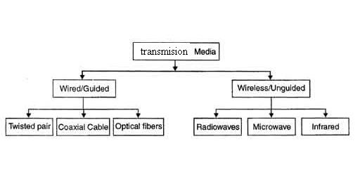

Guided Transmission Media

The three guided media commonly used for data transmission are twisted pair, coaxial cable, and optical fiber. A signal traveling along any of these media is directed and contained by the physical limits of the medium. Twisted-pair and coaxial cable use metallic (copper) conductors that accept and transport signals in the form of electric current. Optical fiber is a cable that accepts and transports signals in the form of light.

Twisted Pair
The most common guided transmission medium for both analog and digital signals is twisted pair. The least expensive than the other commonly used guided transmission media (coaxial cable, optical fiber) and most widely used guided transmission medium.
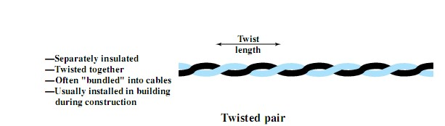
A twisted pair consists of two insulated copper wires arranged in a regular spiral pattern. A wire pair acts as a single communication link. Typically, a number of these pairs are bundled together into a cable by wrapping them in a tough protective sheath. The twisting tends to decrease the crosstalk interference between adjacent pairs in a cable. Twisted pair comes in two varieties:
Unshielded Twisted Pair (UTP) Cable :
Unshielded twisted pair is the most common kind of copper telephone wiring. Twisted pair is the ordinary copper wire that connects home and many business computers to the telephone company. To reduce crosstalk or electromagnetic induction between pairs of wires, two insulated copper wires are twisted around each other.

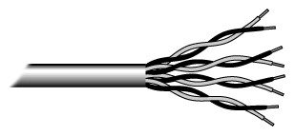

UTP Cables
The quality of UTP may vary from telephone-grade wire to extremely high-speed cable. The cable has four pairs of wires inside the jacket. Each pair is twisted with a different number of twists per inch to help eliminate interference from adjacent pairs and other electrical devices. The EIA/TIA (Electronic Industry Association/Telecommunication Industry Association) has established standards of UTP and rated five categories of wire.

Type | Use
Category 1 | Voice Only (Telephone Wire)
Category 2 | Data to 4 Mbps (LocalTalk)
Category 3 | Data to 10 Mbps (Ethernet)
Category 4 | Data to 20 Mbps (16 Mbps Token Ring)
Category 5 | Data to 100 Mbps (Fast Ethernet)
Unshielded Twisted Pair Connector:
The standard connector for unshielded twisted pair cabling is an RJ-45 connector. This is a plastic connector that looks like a large telephone-style connector .A slot allows the RJ-45 to be inserted only one way. RJ stands for Registered Jack, implying that the connector follows a standard borrowed from the telephone industry. This standard designates which wire goes with each pin inside the connector.
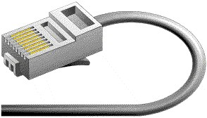

RJ45 Connector
Shielded Twisted Pair (STP) Cable :
Although UTP cable is the least expensive cable, it may be susceptible to radio and electrical frequency interference (it should not be too close to electric motors, fluorescent lights, etc.). If you must place cable in environments with lots of potential interference, or if you must place cable in extremely sensitive environments that may be susceptible to the electrical current in the UTP, shielded twisted pair may be the solution. Shielded cables can also help to extend the maximum distance of the cables.
Shielded twisted pair cable is available in three different configurations:
- Each pair of wires is individually shielded with foil.
- There is a foil or braid shield inside the jacket covering all wires (as a group).
- There is a shield around each individual pair, as well as around the entire group of wires (referred to as double shield twisted pair).
Coaxial Cable:
A type of wire that consists of a center wire surrounded by insulation and then a grounded shield of braided wire. The shield minimizes electrical and radio frequency interference.

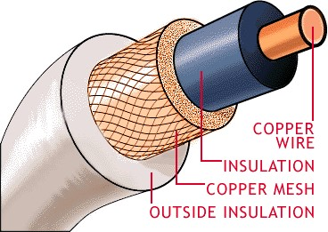

Coaxial Cable
Coaxial cabling is the primary type of cabling used by the cable television industry and is also widely used for computer networks, such as Ethernet. Although more expensive than standard telephone wire, it is much less susceptible to interference and can carry much more data.
The two types of coaxial cabling are thick coaxial and thin coaxial.
Thin coaxial cable is also referred to as thin net. 10Base2 refer to the specifications for thin coaxial cable carrying Ethernet signals. The 2 refer to the approximate maximum segment length being 200 meters. In actual fact the maximum segment length is 185 meters. Thin coaxial cable is popular in school networks, especially linear bus networks.
Thick coaxial cable is also referred to as thick net. 10Base5 refer to the specifications for thick coaxial cable carrying Ethernet signals. The 5 refer to the maximum segment length being 500 meters. Thick coaxial cable has an extra protective plastic cover that helps keep moisture away from the center conductor. This makes thick coaxial a great choice when running longer lengths in a linear bus network. One disadvantage of thick coaxial is that it does not bend easily and is difficult to install.
Coaxial Cable Connectors:
The most common type of connector used with coaxial cables is the Bayone-Neill-Concelman (BNC) connector. Different types of adapters are available for BNC connectors, including a Tconnector, barrel connector, and terminator. Connectors on the cable are the weakest points in any network. To help avoid problems with your network, always use the BNC connectors that crimp, rather than screw, onto the cable.
 BNC Connector
Fiber Optic Cable:
Instead of insulated metal wires transmitting electrical signals, fiber optic network cables work using strands of glass and pulses of light. These network cables are bendable despite being made of glass. They have proven especially useful in wide area network (WANs)installations where long distance underground or outdoor cable runs are required and also in office buildings where a high volume of communication traffic is common.
Two primary types of fiber optic cable industry standards are defined – single-mode (100BaseBX standard) and multimode (100BaseSX standard). Long-distance telecommunications networks more commonly use single-mode for its relatively higher bandwidth capacity, while local networks typically use multimode instead due to its lower cost.



Facts about fiber optic cables:
- Outer insulating jacket is made of Teflon or PVC.
- Kevlar fiber helps to strengthen the cable and prevent breakage.
- A plastic coating is used to cushion the fiber center.
- Center (core) is made of glass or plastic fibers.
Fiber Optic Connector :
Most fiber optic connectors are plugs or so-called male connectors with a protruding ferrule that holds the fibers and aligns fibers for mating. They use a mating adapter to mate the two connector ferrules that fits the securing mechanism of the connectors (bayonet, screw-on or snapin.) The ferrule design is also useful as it can be used to connect directly to active devices like LEDs, VCSELs and detectors.

Specificatio n | Cable Type | Maximum length
10BaseT | Unshielded Twisted  Pair | 100 meters
10Base2 | Thin Coaxial | 185 meters
10Base5 | Thick Coaxial | 500 meters
10BaseF | Fiber Optic | 2000 meters

Installing Cable - Some Guidelines:
When running cable, it is best to follow a few simple rules:
- Always use more cable than you need.
- Test every part of a network as you install it. Even if it is brand new, it may have problems that will be difficult to isolate later.
- Stay at least 3 feet away from fluorescent light boxes and other sources of electrical interference.
- If it is necessary to run cable across the floor, cover the cable with cable protectors.
- Label both ends of each cable.
- Use cable ties (not tape) to keep cables in the same location together.

Lab # 03(b)

Cables and Connectors

To Study about basics of straight through and cross-over cable and its connector.

THEORY
STRAIGHT CABLE:
Straight cable usually uses to connect different type of devices.
EXAMPLES:
- Connect a computer to a switch/hub's normal port.
- Connect a computer to a cable/DSL modem's LAN port.
- Connect a router's WAN port to a cable/DSL modem's LAN port.
- Connect a router's LAN port to a switch/hub's uplink port. (normally used for expanding network)
- Connect 2 switches/hubs with one of the switch/hub using an uplink port and the other one using normal port.
CROSS CABLE:
Cross cable usually used to connect same type of devices.
EXAMPLES:
- Connect 2 computers directly.
- Connect a router's LAN port to a switch/hub's normal port. (normally used for expanding network.)
- Connect 2 switches/hubs by using normal port in both switches/hubs.
Examples
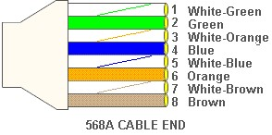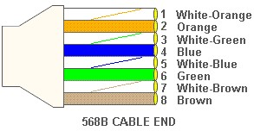
To Make Cables:
STRAIGHT THROUGH CABLES:
Requirements: Two RJ45 Connectors, Crimping tool & CAT 5 cable of desired length(less than 250 meters).
Steps:
- Measure out the distance between the two devices you want to connect with the straight through cable. Acquire a length of Cat5 Ethernet cable that is at least one foot longer than the measured distance to account for any mistakes made while cutting the cable.
- Place one inch of either end of the Cat5 cable into the stripping hole in the crimp tool. Squeeze the handles of the crimp tool slightly to cut into the outer covering of the Cat5 cable.
- Pull the crimp tool away from you to remove the outer covering from the inner strands of cable. Untwist each of the colored cable strands.
- Arrange the colored strands, from left to right, in the correct order for a straight through cable. Line-up the strands in the order of white/orange, orange, white/green, blue, white/blue, green, white/brown, and then brown.
- Snip off the ends of the colored wires with the cutting edge of the crimp tool to make sure they are all uniform length. Insert the colored cables into the plastic RJ-45 connector.
- Place the RJ-45 connector into the crimping hole on the crimp tool. Squeeze the crimp tools handles all the way down to crimp the RJ-45 connector onto the Cat5 cable.
- Repeat the process of stripping, cutting, arranging, and crimping the other end of the Cat5 Ethernet cable.
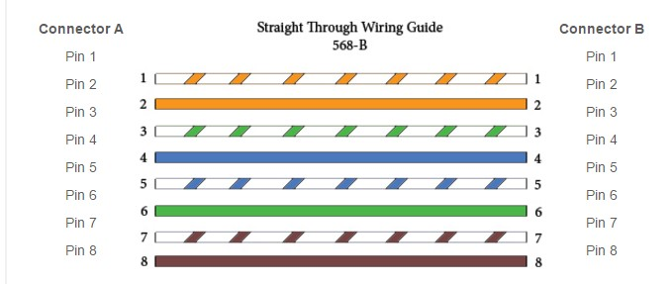
CROSS CABLES:
- Find a standard Ethernet cable you don't use for anything.
- Towards one end of the cable, cut open a slit a few inches long. Be careful not to damage the wiring inside the cable or cut yourself.
- Peel back and remove the cable casing. This will leave the inner wiring exposed.
Examine how the wiring is twisted together and note the colors of the wires.
- With the wires cut, work now one-by-one.
- On Side "A" we will call it, connect the end to the end on Side "B".
- You now have one step of your crossover wire completed.
- Now repeat the process with the final two wires.
- Twist the wires together and fix with tape.
- Join the remaining wires.
- Note the direction that the wiring in the cable case is twisting.

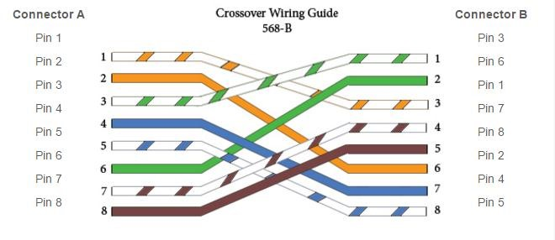

UNSHIELDED TWISTED PAIR CABLE:
Unshielded twisted pair is the most common kind of copper telephone wiring. Twisted pair is the ordinary copper wire that connects home and many business computers to the telephone company.
- Consists of 4 pairs (8 wires) of insulated copper wires typically about 1 mm thick.
- The wires are twisted together in a helical form.
- Twisting reduces the interference between pairs of wires.
- High bandwidth and High attenuation channel.
- Flexible and cheap cable.
- Category rating based on number of twists per inch and the material used.
- CAT 3, CAT 4, CAT 5, Enhanced CAT 5 and now CAT 6.
CAT 5:
CAT 5 is an Ethernet network cable standard defined by the Electronic Industries Association and Telecommunications Industry Association (commonly known as EIA/TIA). CAT5 is the fifth generation of twisted pair Ethernet technology and the most popular of all twisted pair cables in use today.
- Network support - CAT 5 cable will support 10/100 Ethernet. That is, Ethernet and Fast Ethernet.
- Less cross talk - Cross talk is the electrical interference that result’s when one wire's signal effect’s another wire's signal.
- Bandwidth - This is directly related to network support, in the sense that the bandwidth is the information-carrying capacity of a system. The greater the bandwidth, the greater the information-carrying capacity in a given period of time.
CONNECTOR (RJ 45):
A registered jack (RJ) is a standardized physical network interface for connecting telecommunications or data equipment. The physical connectors that registered jacks use are mainly of the modular connector and 50-pin miniature ribbon connector types. The most common twisted-pair connector is an 8-position, 8-contact (8P8C) modular plug and jack commonly referred to as an RJ45 connector.
A slot allows the RJ-45 to be inserted only one way, implying that the connector follows a standard borrowed from the telephone industry. This standard designates which wire goes with each pin inside the connector.
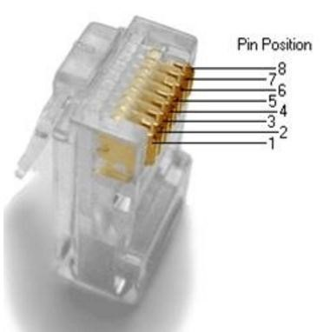
NETWORK CABLE TOOLS:
  - Cable Jacket Stripper.
  - CI-KIT
  - CI-KIT2
  - CPT
  - CPT-WEB
  - Cutter
  - Electrician's Scissors
  - MAX TurboTool
  - Palm Guard
  - Probe-Pic
  - PT-908 Crimp Tool
  - RG6 F-Type Termination Tool
  - S110/S210 Multi-Pair Termination Tool
  - S814 Impact Tool
  - TERA Cable Preparation Tool
  - XLR8 Fiber Termination Kit
  - Z-MAX Z-TOOL
EXERCISES

Q.1) What is the significance of twisting in twisted pair copper wires?

Q.2) What is the difference between unshielded and shielded twisted pair wires?

Q.3) What is the difference between guided and unguided medium?

Q.4) What are the application of fiber optics,twisted pair and coaxial cables?

Q.5) What is the position of transmission media in OSI model?

Q.6) Just name the components of optical fiber cables?

Q.7) What are the usage of straight and cross over cables?

Lab # 04 OBJECT

In this lab, you will learn how to design an IP address scheme for your company Network and minimized the wastage of IP Addresses by doing
Subnetting

THEORY

IP Addressing:
An IP address is an address refers to the Internet Protocol used in order to uniquely identify a device on an IP network. The 32 binary bits are broken into four octets (1 octet = 8 bits). Each octet is converted to decimal and separated by a period (dot). For this reason, an IP address is said to be expressed in dotted decimal format (for example, 172.16.81.100). The value in each octet ranges from 0 to 255 decimal, or 00000000 - 11111111 binary.
For example 205.112.45.60 could be written as:
11001101.01110000.00101101.00111100
The address is made up of 32 binary bits, which can be divisible into two parts by their subnet mask:
Network portion
Host portion

Network bits | Host bits

172 | . | 16 | . | 9 | . | 1
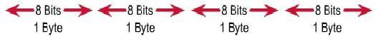

Classful Addressing:
IPv4 addressing used the concept of classes. This architecture is called classful addressing. The address space is divided into five classes: A, B, C, D, and E. Each class occupies some part of the address space.
We can find the class of an address when given the address in
Binary notation or dotted-decimal notation.If the address is given in binary notation, the first few bits can immediately tell us the class of the address. If the address is given in decimal- dotted notation, the first byte defines the class

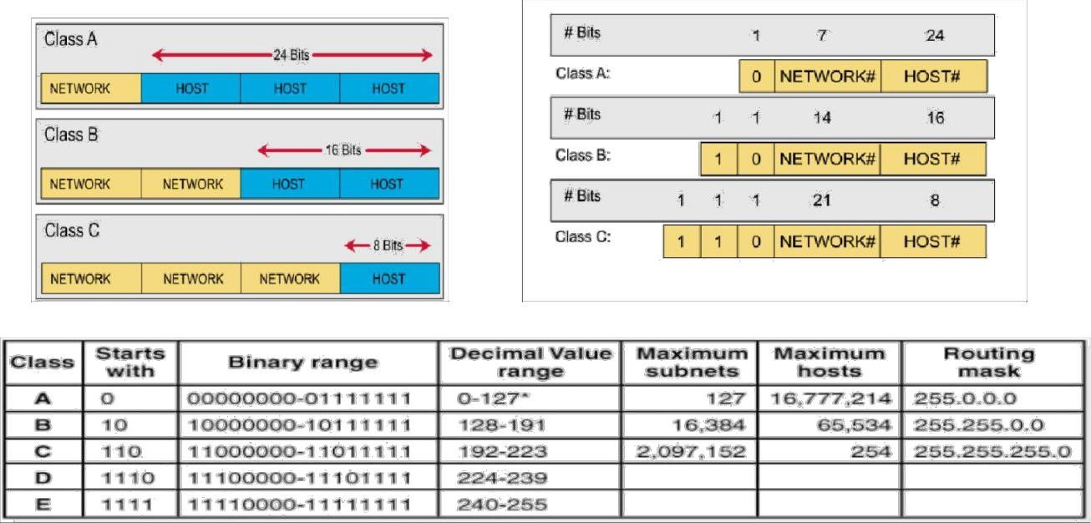
0 [Zero] is reserved and represents all IP addresses.
127 is a reserved address and is used for testing, like a loop back on an interface.

Subnetting:

Subnetting is a process of breaking large network in small networks known as subnets. Subnetting happens when we extend default boundary of subnet mask. Basically we borrow host bits to create networks.
With subnetting you only need to purchase single range of class C. You can configure router to take first 26 bits instead of default 24 bits as network bits. In this case we would extend default boundary of subnet mask and borrow 2 host bits to create networks. By taking two bits from the host range and counting them as network bits, we can create two new subnets, and assign hosts them. As long as the two new network bits match in the address, they belong to the same network. You can change either of the two bits, and you would be in a new subnet.
Subnet mask:
A 32-bit Subnet mask used to describe which portion of an address refers to the network and which part refers to the host. Subnet Mask is made by setting network bits to all "1"s and setting host bits to all "0"s.
* Follow these steps to determine the subnet mask:
Express the subnetwork IP address in binary form.
Replace the network and subnet portion of the address with all 1s.
Replace the host portion of the address with all 0s.
Convert the binary expression back to dotted-decimal notation.

For example if you have an IP address is 192.168.1.10 so we need subnet mask to get details about network address and host address. In decimal notation
IP address 192.168.1.10
Subnet mask 255.255.255.0
Network address is 192.168.1 and host address is 10.
In binary notation
IP address 11000000.10101000.00000001.00001010 Subnet mask 11111111.11111111.11111111.00000000
Network address is 11000000.10101000.00000001 and host address is 00001010
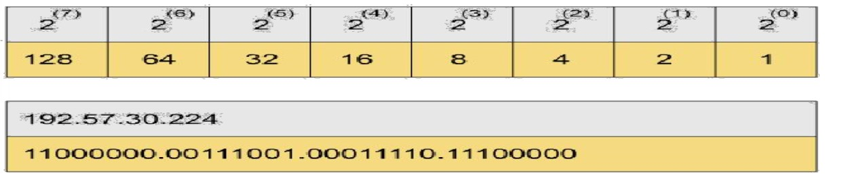

Classless Inter Domain Routing(CIDR)

Class A has default subnet mask 255.0.0.0. that means first octet of the subnet mask has all on bits. In slash notation it would be written as /8, means address has 8 bits on. Class B has default subnet mask 255.255.0.0. that means first two octets of the subnet mask have all on bits. In slash notation it would be written as /16, means address has 16 bits on.
Class C has default subnet mask 255.255.255.0. that means first three octets of the subnet mask have all on bits. In slash notation it would be written as /24, means address has 24 bits on.

Subnetting Class C Addresses
In a Class C address, the first 3 octets i.e. 24 bits are defining the network and only 8 bits are available for defining the hosts. Class C IP addresses range from 192 to 223.The default subnet mask for Class C is 255.255.255.0 . CIDR notation of class C is /24, which means 24 bits from IP address are already consumed by network portion and we have 8 host bits to work with.
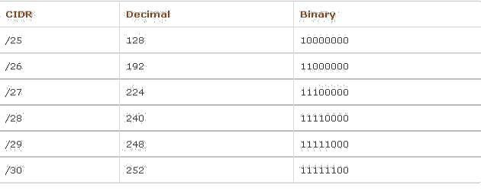

Subnetting Class B Addresses
In a Class B address, the first 2 octets i.e. 16 bits are defining the network and only 16 bits are available for defining the hosts. Class C IP addresses range from 128 to 191.The default subnet mask for Class C is 255.255.0.0

Subnetting Class A Addresses
In a Class A address, the first octets i.e. 8 bits are defining the network and only 24 bits are available for defining the hosts. Class C IP addresses range from 0 to 127.The default subnet mask for Class C is 255.0.0.0

Subnetting Class D Addresses
A Class D address begins with binary 1110 in the first octet. First octet range 224 to 239.Class D address can be used to represent a group of hosts called a host group, or multicast group.

Subnetting Class E Addresses
First octet of an IP address begins with 1111.First octet range 240 to 255. Class E addresses are reserved for experimental purposes and should not be used for addressing hosts or multicast groups.

How to find subnet mask of a given IP address?
We cannot perform subnetting with default subnet mask and every classes have default subnet mask. Now find the host bits borrowed to create subnets and convert them in decimal. For example find the subnet mask of address 188.25.45.48/20 ? This address belong to class B and class B has default subnet mask 255.255.0.0[ /16 in CIDR. We borrowed 4 bits from hosts portion. As you know subnetting move from left to right and it cannot skip any network bit. So this subnet mask in binary would be 11111111. 11111111.11110000.00000000.In our example it would be 128+64+32+16+0+0+0+0 = 240. Our fourth octet has all bits off so its decimal value would be 0+0+0+0+0+0+0+0 =0. Our answer subnet mask would be 255.255.240.0

How many subnets?
2 11000000x = number of subnets. x is the number of masked bits, or the 1s. For example, in, the number of ones gives us 22 subnets. In this example, there are 4 subnets.

What are the valid subnets and block size?
256 – subnet mask = block size, or increment number. An example would be 256 – 192 = 64. The block size of a 192 mask is always 64. Start counting at zero in blocks of 64 until you reach the subnet mask value and these are your subnets. 0, 64, 128, 192.

What are the total hosts per subnet?
Total hosts are the hosts available per subnet. To calculate total hosts use formula 2^{y} =
Total hosts. y is the number of host bits. For example in address 192.168.1.0/26 we have
32 - 26 [Total bits in IP address - Bits consumed by network address] = 6. Total hosts per subnet would be 2⁶ = 64.

How many valid hosts per subnet?
2y– 2 = number of hosts per subnet. y is the number of unmasked bits, or the 0s. For example, in 11000000, the number of zeros gives us 26 – 2 hosts. In this example, there are 62 hosts per subnet. You need to subtract two for the subnet address or starting address and the broadcast address, which are not valid host. Valid hosts are the numbers between the subnets omitting all the 0s and all 1s. For example, if 64 is the subnet number and 12 is the broadcast address, then
65–126 is the valid host range—it’s always the numbers between the subnet address and the broadcast address.

What is broadcast address of each subnet?
Broadcast address is the last address of subnet. This address is reserve for network broadcast, and cannot be assigned to any host. In above example

0 Subnet has broadcast address 63
64 Subnet has broadcast address 127
128 Subnet has broadcast address 191
192 Subnet has broadcast address 255

What is the network address of each subnet?

Network address is the first address of subnet. This address is used to locate the network, and cannot be assigned to any host. In above example address 0,64,128,192 are the network address.Network address is always the first IP address of subnet. Broadcast address is always the last IP address of subnet ( IP address before the next subnet). Valid hosts are the IP addresses between network address and broadcast address.

Topology:

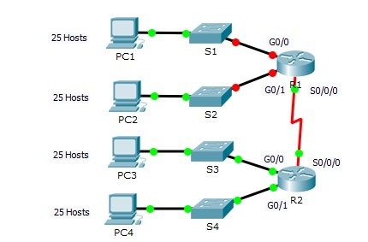

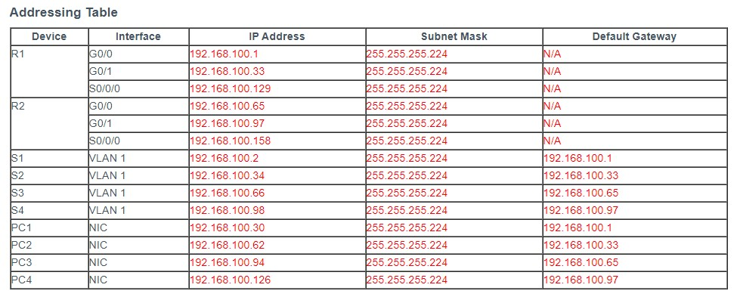

LAB TASK:

- Design an IP Addressing Scheme. Subnet the 192.168.100.0/24 network into the appropriate number of subnets.
- Assign IP Addresses to Network Devices and Verify Connectivity

6
EXERCISES:

- Based on the topology, how many subnets are needed?

__________________________________________________________________ __________________________________________________________________

- Why we divide the range of ip address from 0 to 255 in classes?

__________________________________________________________________

- What is CIDR or slash notation. Give the maximum and minimum range of each class.

__________________________________________________________________
__________________________________________________________________
__________________________________________________________________

- Find the subnet mask only of the following ip address:

a) 192.168.60.20/28 b)202.50.6.7/26 c) 215.54.7.80/29

__________________________________________________________________
__________________________________________________________________ __________________________________________________________________

Lab # 05(a) OBJECT

In this lab, you will learn how to verify Default VLAN configuration,
configure VLANs and assign ports to VLANs

THEORY

VLAN:

VLANs allow network administrators to partition their networks to match the functional and security requirements of their systems without having to run new cables or make major changes in their current network infrastructure. Virtual LANs (VLANs) provide segmentation and organizational flexibility in a switched network. A group of devices within a VLAN communicate as if each device was attached to the same cable. VLANs are based on logical connections, instead of physical connections.

Benefits of a VLAN Design

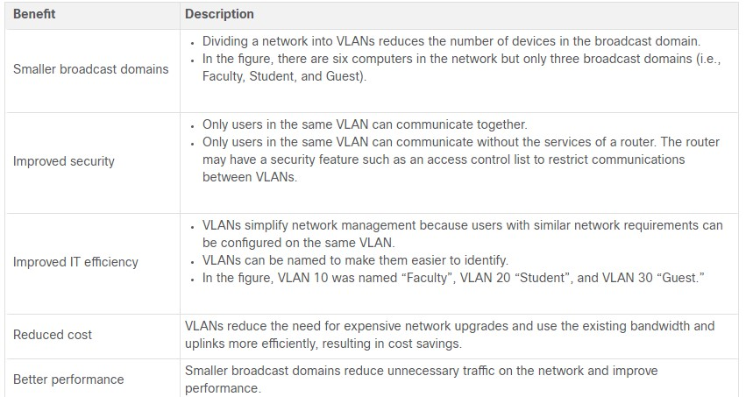

Types of VLANs:

- Default VLAN
- Data VLAN
- Native VLAN
- Management VLAN
- Voice VLAN

Topology:

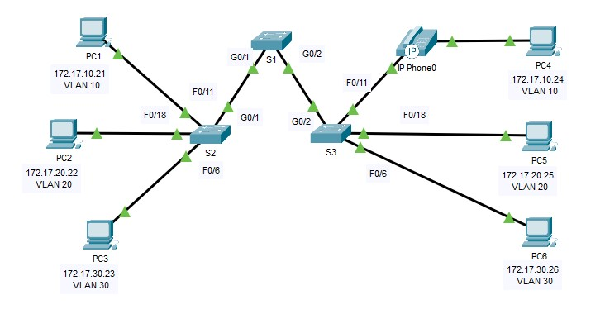

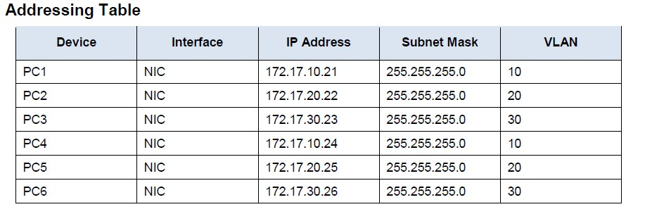

LAB TASK:

- On S1, issue the command that displays all VLANs configured
- Create and name VLANs on S1.
S1#(config)# vlan 10
S1#(config-vlan)# name Faculty/Staff
- Create the remaining VLANS.
VLAN 20: Students
VLAN 30: Guest(Default)
VLAN 99: Management&Native
VLAN 150: VOICE
- Create the same VLANs on S2 and S3.
- Assign VLANs to the active ports on S2
S2(config)# interface f0/11
S2(config-if)# switchport mode access
S2(config-if)# switchport access vlan 10
- Assign the remaining ports to the appropriate VLAN.
VLAN 20: FastEthernet 0/18
VLAN 30: FastEthernet 0/6
- S3 uses the same VLAN access port assignments as S2. Configure the interfaces as access ports and assign the VLANs as follows:
VLAN 10: FastEthernet 0/11
VLAN 20: FastEthernet 0/18
VLAN 30: FastEthernet 0/6
- Assign the VOICE VLAN to FastEthernet 0/11 on S3.
S3(config)# interface f0/11
S3(config-if)# mls qos trust cos
S3(config-if)# switchport voice vlan 150
- Verify loss of connectivity. Try pinging between PC1 and PC4.
S2# show vlan brief
Although the access ports are assigned to the appropriate VLANs, were the pings successful? Explain.

EXERCISES:

- Which command will only display the VLAN name, status, and associated ports on a switch?

__________________________________________________________________ __________________________________________________________________

- What is the Advantage of using the VLANs in your Network?

__________________________________________________________________

Lab # 05(b) OBJECT

In this lab, you will learn about VLAN Trunking Protocol (VTP) and its
Implementation

THEORY

VLAN Trunking Protocol (VTP) :
VTP is CISCO proprietary protocol used to maintain consistency throughout the network or user can say that synchronizing the VLAN information in same VTP domain. VTP allows you to add, delete and rename VLANs which is then propagated to other switches in the VTP domain. VTP advertisements can be sent over 802.1Q, and ISL trunks.

Requirements –

There are some requirements for VTP to communicate VLAN information between switches. These are:

- The VTP version must be same on the switches user wants to configure
- VTP domain name must be same on the switches
- One of the switches must be a server
- Authentication should match if applied

VTP Modes:

VTP server mode – the default mode for Cisco switches. A switch operating in this mode can create, modify, and delete VLANs. You can also specify other VTP configuration parameters on a VTP server, such as VTP version and VTP pruning, for the entire VTP domain. A VTP server switch will propagate VLAN changes. To configure a switch as a VTP server, use the vtp mode server global configuration command.
VTP client mode – a switch operating in this mode can’t change its VLAN configuration. You cannot create, change, or delete VLANs on a VTP client. Received VTP updates will be processed and forwarded. To configure a switch as a VTP client, use the vtp mode client global configuration command.
VTP transparent mode – a switch opering in this mode doesn’t participate in VTP. A VTP transparent switch does not advertise its VLAN configuration and does not synchronize its VLAN configuration based on received advertisements, but it does forward received VTP advertisements. You can create and delete VLANs on a VTP transparent switch, but the changes will not be sent to other switches. To configure a switch to use the VTP transparent mode, use the vtp mode transparent global configuration command.

Topology:

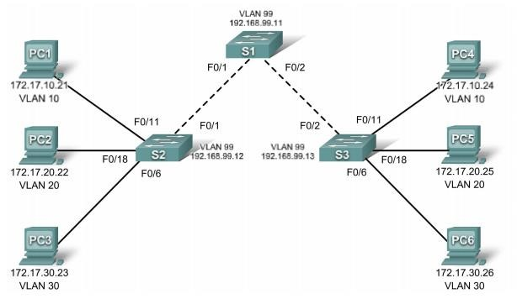

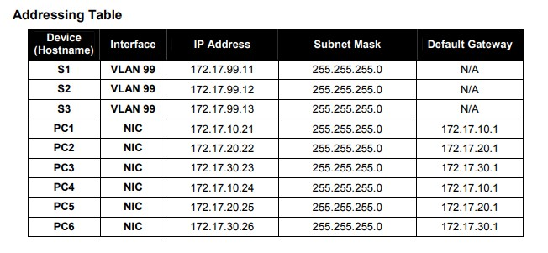

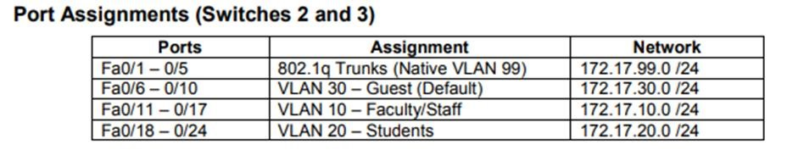

LAB TASK:

- Cable a network that is similar to the one in the topology diagram.
- Configure the user ports in access mode. Refer to the topology diagram to determine which ports are connected to end-user devices.
- Configure VTP on the Switches
- Check the current VTP settings on the three switches. S1#show vtp status
- Configure the operating mode, domain name, and VTP password on all three switches.
Set the VTP domain name to Lab4 and the VTP password to cisco on all three switches. Configure S1 in server mode, S2 in client mode, and S3 in transparent mode.
S1(config)#vtp mode server
Device mode already VTP SERVER.
S1(config)#vtp domain Lab4
Changing VTP domain name from NULL to Lab4
S1(config)#vtp password cisco
Setting device VLAN database password to cisco
S1(config)#end
S2(config)#vtp mode client
Setting device to VTP CLIENT mode
S2(config)#vtp domain Lab4
Changing VTP domain name from NULL to Lab4
S2(config)#vtp password cisco
Setting device VLAN database password to cisco
S2(config)#end
S3(config)#vtp mode transparent
Setting device to VTP TRANSPARENT mode.
S3(config)#vtp domain Lab4
Changing VTP domain name from NULL to Lab4
S3(config)#vtp password cisco
Setting device VLAN database password to cisco
S3(config)#end
- Configure trunking and the native VLAN for the trunking ports on all three switches.
S1(config)#interface range fa0/1-5
S1(config-if-range)#switchport mode trunk
S1(config-if-range)#switchport trunk native vlan 99
S1(config-if-range)#no shutdown
S1(config-if-range)#end
- Configure VLANs on the VTP server
There are four additional VLANS required in this lab:
  - VLAN 99 (management)
  - VLAN 10 (faculty/staff)
  - VLAN 20 (students)
  - VLAN 30 (guest)
Configure these on the VTP server.
S1(config)#vlan 99
S1(config-vlan)#name management
S1(config-vlan)#exit
S1(config)#vlan 10
S1(config-vlan)#name faculty/staff
S1(config-vlan)#exit
S1(config)#vlan 20
S1(config-vlan)#name students
S1(config-vlan)#exit
S1(config)#vlan 30
S1(config-vlan)#name guest
S1(config-vlan)#exit

- Verify that the VLANs have been created on S1 with the show vlan brief command.
- Check if the VLANs created on S1 have been distributed to S2 and S3
S2#show vlan brief

EXERCISES:

- Based on the topology, Are the same VLANs configured on all switches?

__________________________________________________________________ __________________________________________________________________

- Explain why S2 and S3 have different VLAN configurations?

__________________________________________________________________

- When you try to create new VLAN on S2 and S3, Why are you prevented from creating a new VLAN on S2 but not S3?

__________________________________________________________________
__________________________________________________________________
__________________________________________________________________

- What are the Advantages of using VTP?

__________________________________________________________________
__________________________________________________________________ __________________________________________________________________

Lab # 06
OBJECT

In this lab, you will perform basic switch configuration tasks. You will secure access to the command-line interface (CLI) and console ports using encrypted and plain text passwords. You will also learn how to
configure messages for users logging into the switch.

THEORY

Switch:

A network switch (also called switching hub, bridging hub, and, by the IEEE, MAC bridge) is networking hardware that connects devices on a computer network by using packet switching to receive and forward data to the destination device..

Types of Switches:

The transport, network, data link, and physical layers of the OSI Model each have a different protocol data unit (PDU):

There are two main categories of switches: modular and fixed configuration. There are variations among these categories of network switches, but the primary definition of each remains the same.

Modular switches:

Modular switches let you add expansion modules as needed, giving you flexibility as network requirements change. Expansion modules are application-specific and include those for firewalls, wireless connectivity, or network analysis. They may also allow for additional interfaces, power supplies, or cooling fans. This type of switch provides you with the most flexibility, but at a higher cost.

Fixed-configuration switches:

Fixed-configuration switches provide a fixed number of ports and are typically not expandable, which makes them less expensive overall. Fixed-configuration switches include unmanaged switches, smart switches, and managed switches.

Unmanaged switches:

Unmanaged switches are typically used to provide basic connectivity. They're designed to be plug and play; no configuration is needed. Unmanaged switches are most effective when only basic switching and connectivity are required. You will often see them in home networks or wherever only a few ports are needed, such as at a desk, in a lab, or in a conference room.

Some unmanaged switches do offer limited advanced capabilities, however—as the name implies—these switches generally cannot be modified or managed.

Smart switches:

Smart switches offer some management and segmentation, quality of service, and security capabilities, so they can be a cost-effective alternative to modular switches. Still, they are not as scalable as managed switches. These switches are typically deployed at the edge of a large network (while managed switches are used in the core), as the infrastructure for smaller networks, or for low complexity networks.

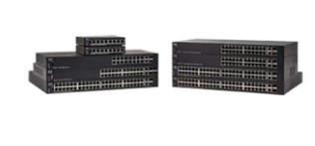

Managed switches:

Among fixed-configuration switches, managed switches are designed to deliver the most comprehensive set of features to provide the best application experience, the highest levels of security, the most precise control and management of the network, and the greatest scalability. As a result, managed switches are usually deployed as aggregation/access switches in very large networks or as core switches in smaller networks.

Managed switches are the most expensive option of fixed-configuration switches and are most common in organizations with large- or growing- networks.

Topology:

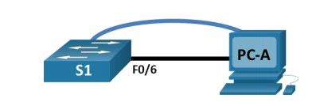

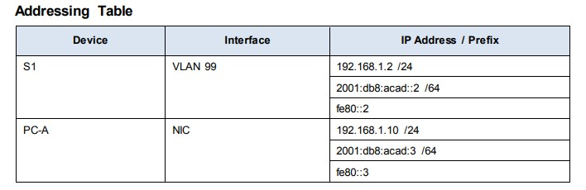

LAB TASK:

- Enter privileged EXEC mode.

  - Click S1 and then the CLI tab. Press Enter.
  - Enter privileged EXEC mode by entering the enable command:
Open Configuration Window for S1
Switch> enable
Switch#
Notice that the prompt changed to reflect privileged EXEC mode.

- Examine the current switch configuration.

Enter the show running-config command.
Switch# show running-config Answer the following questions:
  - How many Fast Ethernet interfaces does the switch have?
  - How many Gigabit Ethernet interfaces does the switch have?

- Assign a name to a switch.
Switch# configure terminal
Switch(config)# hostname S1
S1(config)# exit

- Secure access to the console line.
S1# configure terminal
Enter configuration commands, one per line. End with CNTL/Z.
S1(config)# line console 0
S1(config-line)# password letmein
S1(config-line)# login
S1(config-line)# exit
S1(config)# exit

- Verify that console access is secured.
S1# exit
Switch con0 is now available Press RETURN to get started.
User Access Verification
Password:
S1>

- Secure privileged mode access.

Set the enable password to c1$c0. This password protects access to privileged mode. Note: The 0 in c1$c0 is a zero, not a capital O. This password will not grade as correct until after you encrypt it in Step 8.
S1> enable
S1# configure terminal
S1(config)# enable password c1$c0
S1(config)# exit

- Verify that privileged mode access is secure.

  - Enter the exit command again to log out of the switch.
  - Press <Enter> and you will now be asked for a password:

- Configure an encrypted password to secure access to privileged mode.

The enable password should be replaced with the newer encrypted secret password using the enable secret command. Set the enable secret password to itsasecret.
S1# config t
S1(config)# enable secret itsasecret
S1(config)# exit

- Configure a message of the day (MOTD) banner.
S1# config t
S1(config)# banner motd "This is a secure system. Authorized Access Only!" S1(config)# exit

- Save and Verify Configuration Files to NVRAM
S1# copy running-config startup-config

- Examine flash memory. Switch# show flash Switch# dir flash:
- Configure an IP address on PC-A.
- Verify and Test Network Connectivity

EXERCISES:

- How many FastEthernet interfaces does a 2960 switch have?

__________________________________________________________________ __________________________________________________________________

- What is the Cisco IOS version that the switch is running?

__________________________________________________________________

- What is the MAC address of the interface fa 0/6?

__________________________________________________________________
__________________________________________________________________
__________________________________________________________________

- What is the filename of the Cisco IOS image?

__________________________________________________________________
__________________________________________________________________ __________________________________________________________________

Lab # 07

OBJECT
To implement different topologies on packet tracer. To study how router will configure through different networks. Implementation of IVR
Introduction
we learnt how VLANs segment broadcast traffic on a switch and segment a switched network into different LANs, we also learnt how VLAN information can be transmitted to other switches in the network using VTP and how we can avoid layer two loops using STP.
Consider, this, as the network administrator, one of your tasks is to create and assign different users to VLANs in your network, you have three main departments which should be logically segmented using VLANs, VLAN 10 – FINANCE, VLAN 20 – SALES and VLAN 30 – HR.
The use of VLANs means that users would not be able to communicate across departments, i.e. a user in FINANCE, would not be able to send a message to a user in SALES since they are on different broadcast domains.
In many enterprises, you will find that information sharing across departments is a requirement, therefore, the question begs, how do you make users in the SALES and FINANCE department communicate, yet they are on different VLANS?
In this chapter, we will discuss the role played by inter-VLAN routing in communication between different VLANs. We will learn how it works, consider the various methods that can be used to implement it, configure inter-VLAN routing using router-on-a-stick and traditional inter-VLAN routing, compare the two styles of implementation and finally verify and troubleshoot inter-VLAN routing.
Introduction to inter-vlan routing
When we learnt about VLANs, we said that each VLAN is usually on its own subnet, switches mainly operate at layer 2 of the OSI model and therefore they do not examine the logical addresses. Therefore, user nodes located on different VLANs cannot communicate by default. In many cases, we may need connectivity between users located on different VLANs. The way this can be accomplished is through inter-VLAN routing.
In this course, we will look at one type of inter-VLAN routing, which is through the use of a router.
Definition
Inter-VLAN routing can be defined as a way to forward traffic between different VLAN by implementing a router in the network. As we learnt previously, VLANs logically segment the switch into different subnets, when a router is connected to the switch, an administrator can configure the router to forward the traffic between the various VLANs configured on the switch. The user nodes in the VLANs forwards traffic to the router which then forwards the traffic to the destination network regardless of the VLAN configured on the switch.
The figure below, shows how this process works.
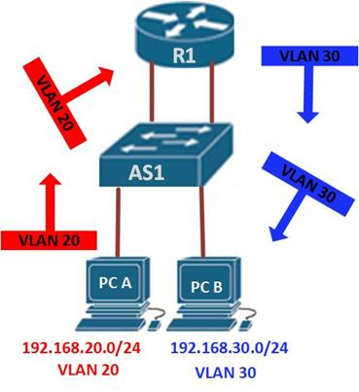
Information destined for PC B, leaves PC A with the VLAN 20 tag, when it gets to R1, the router, changes the format of this message from VLAN 20, to VLAN 30, it then sends it back to the switch and the switch finally sends the message to its intended recipient PC B.
There are two ways in which inter-VLAN routing can be accomplished.
- Traditional inter-VLAN routing
- Router-on-a-stick
Traditional inter-VLAN routing
In this type of inter-VLAN routing, a router is usually connected to the switch using multiple interfaces. One for each VLAN. The interfaces on the router are configured as the default gateways for the VLANs configured on the switch.
The ports that connect to the router from the switch are configured in access mode in their corresponding VLANs.
When a user node sends a message to a user connected to a different VLAN, the message moves from their node to the access port that connects to the router on their VLAN. When the router receives the packet, it examines the packet’s destination IP address and forwards it to the correct network using the access port for the destination VLAN. The switch now can forward the frame to the destination node since the router changed the VLAN information from the source VLAN to the destination VLAN.
In this form of inter-VLAN routing, the router has to have as many LAN interfaces as the number of VLANs configured on the switch. Therefore, if a switch has 10 VLANs, the router should have the same number of LAN interfaces.
Take the scenario shown below.
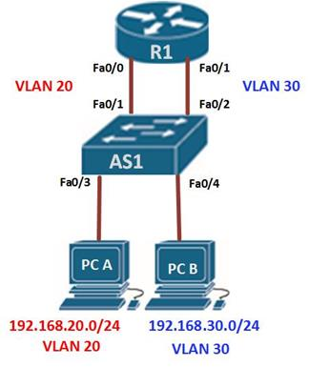
If PC A in VLAN 20, wanted to send a message to PC B in VLAN 30, the steps it would take are shown below.
- PC A would check whether the destination IPv4 address is in its VLAN if it is not, it would need to forward the traffic to its default gateway which is the ip address on Fa0/0 on R1.
- PC A then sends an ARP request to AS1 so as to determine the physical address of Fa0/0 on R1. Once the router replies, PC A can send the frame to the router as a unicast message, since AS1 has Fa0/0’s MAC address, it can forward the frame directly to R1.
- When the router receives the frame, it compares the destination IP address by referring to its routing table so as to know to which interface it should send the data towards the destination node.
- The router then sends an ARP request out the interface connected to the destination VLAN in this case out Fa0/1, when the switch receives the message, it would flood it to its ports and in this case, PC B would reply with its MAC address.
- R1 would then use this information to frame the packet and finally send it to PC B as a unicast frame.
Configuring traditional inter-VLAN routing
In this section, we will configure Inter-VLAN routing on the router and the switch using the scenario we have just seen above. All the VLANs are active and the PCs have been assigned ports, our configuration will only be limited to the router’s inter-VLAN configuration and the switch ports connecting to R1.

The ip addressing in use is shown below.
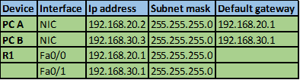
Testing connectivity using the ping command should reveal that PC A cannot ping PC B.
The first step is to configure the switchports to access the specified VLAN, fa0/1 to VLAN 20 and fa0/2 to VLAN 30. This is accomplished using the commands shown below.
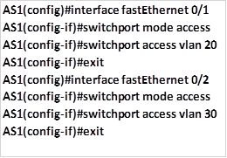
This is the only configuration on the switch, once this is done save the configuration and move on to the router.
On R1, we need to configure its interfaces with the default gateways corresponding to the VLANs. That is; on fa0/0 -192.168.20.1/24 and on fa0/1 – 192.168.30.1/24. We accomplish this using the commands shown below.
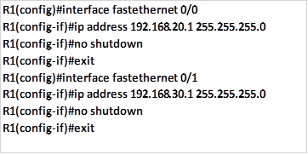
With this configuration we should save and test for connectivity on PC A and PC B, by using the ping command, and the results should be successful. Examining the routing table of R1 should show us the two routes as shown in the output below. This confirms that the router knows of the two VLANs and therefore traffic can flow between them.
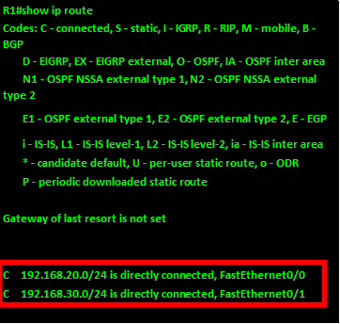
LAB TASK:
1.Design Vlan topology,
2.configure IVR.

Lab # 08

OBJECT

In this lab, you will learn how to configure RIP and its Implementation

THEORY

Routing Information Protocol (RIP)

Routing Information Protocol (RIP) is a dynamic routing protocol which uses hop count as a routing metric to find the best path between the source and the destination network. It is a distance vector routing protocol which has AD value 120 and works on the application layer of OSI model. RIP uses port number 520.

Hop Count:
Hop count is the number of routers occurring in between the source and destination network. The path with the lowest hop count is considered as the best route to reach a network and therefore placed in the routing table. RIP prevents routing loops by limiting the number of hopes allowed in a path from source and destination. The maximum hop count allowed for RIP is 15 and hop count of 16 is considered as network unreachable.

Features of RIP:

- Updates of the network are exchanged periodically.
- Updates (routing information) are always broadcast.
- Full routing tables are sent in updates.
- Routers always trust on routing information received from neighbor routers. This is also known as Routing on rumours.

RIP versions:
There are three vesions of routing information protocol – RIP Version1, RIP Version2 and RIPng.

Topology:

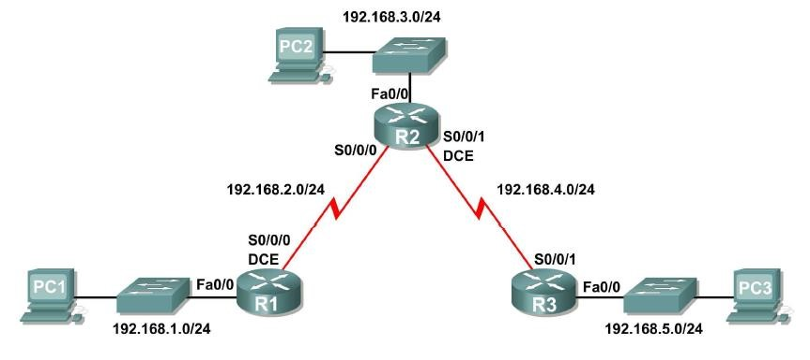

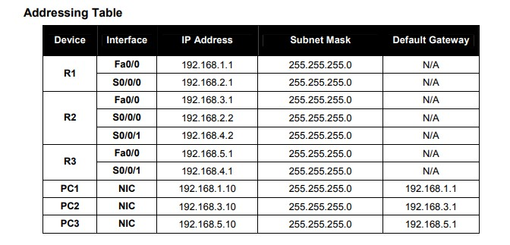

LAB TASK:

  - Configure the routers
  - Add the logging synchronous command to the console and virtual terminal lines Router(config-line)#logging synchronous
  - Disable DNS lookup
Router(config)#no ip domain-lookup
  - Add the logging synchronous command to the console and virtual terminal lines
  - Configure the interfaces on the R1, R2, and R3 routers with the IP addresses from the table under the Topology Diagram.
  - Verify IP addressing and interfaces show ip interface brief
  - Configure Ethernet interfaces of PC1, PC2, and PC3
  - Enable dynamic routing RIP Router(config)#router rip
  - Enter classful network addresses
Router(config-router)#network <network_nr>
Router(config-router)#network <network_nr>
  - Use the show ip route command to verify that each router has all of the networks in the topology entered in the routing table
  - Use the show ip protocols command to view information about the routing processes
  - Use the debug ip rip command to view the RIP messages being sent and received 13. Discontinue the debug output with the undebug all command

EXERCISES:

- What is RIP what is the use of RIP?

__________________________________________________________________ __________________________________________________________________

- Which RIP version supports VLSM?

__________________________________________________________________

Lab # 09

OBJECT
In this lab, you will learn how to configure EIGRP and its Implementation
Two quick things before we start…
- This EIGRP lab and the ones that follow are for you future CCENTs and CCNAs, too!
- This entire whopping EIGRP tutorial section is straight from my CCNP ROUTE Study Guide, available only on Amazon. Check it out when you’re done here!
Now, let’s get started with a quick review of important EIGRP fundamentals before we dive into the lab work!
EIGRP is the enhanced version of the Interior Gateway Routing Protocol (IGRP). IGRP is long gone; it’s no longer supported by Cisco and isn’t on the CCNA or CCNP exams. EIGRP is known as a hybrid protocol, since it officially has characteristics of link state and distance vector protocols. As you’ll see, EIGRP acts much more like an LS protocol than a DV protocol. The main DV behavior shown by EIGRP is the initial exchange of full routing tables between EIGRP neighbors.
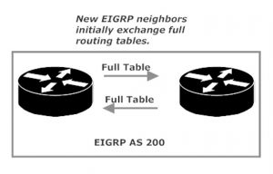
After that initial exchange of full tables, an EIGRP router will send an update only when there’s a change in the network. That update will reflect only those changes and will not consist of a full routing table.
EIGRP brings several major benefits to our network:
- Rapid convergence when a change in the network is detected; backup routes (“feasible successors”) are calculated before they’re actually needed due to the loss of a primary route (“successors”).
- Multiprotocol support, including IP, IPX, and Appletalk
- Support for VLSM and CIDR
Those benefits can’t benefit us until adjacencies form between our EIGRP-speaking routers. Actually, nothing can happen between our EIGRP routers until adjacencies form, so let’s spend some time with the packet that makes these happen.
EIGRP uses Hello packets (multicast to 224.0.0.10) to establish and maintain neighbor relationships. The Reliable Transport Protocol (RTP) is used to handle the transport of messages between EIGRP-enabled routers.
EIGRP uses autonomous systems (AS) to identify routers that belong to the same logical group. EIGRP speakers that are in separate ASes cannot become neighbors.
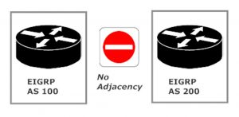
Once the adjacency is formed, it’s kept alive by a steady flow of Hello packets from the neighbor. If those Hellos stop coming, the adjacency is eventually dropped.
The Successor and Feasible Successor
EIGRP keeps three important tables. The route table stores the best route to each remote network the router knows of. The topology table keeps all known valid, loop-free routes to those same networks. Finally, the neighbor table keeps exactly what you’d think it would keep – information on the router’s EIGRP neighbors.
The route and topology tables play a vital role in EIGRP’s rapid recovery from a lost route. Here, R1 has two paths to R4. EIGRP has determined the path through R2 is the best. That route will be placed into both the route and topology tables. The route through R3 is valid and has been determined by EIGRP to be free of routing loops, so that route (a feasible successor) is placed into the topology table.
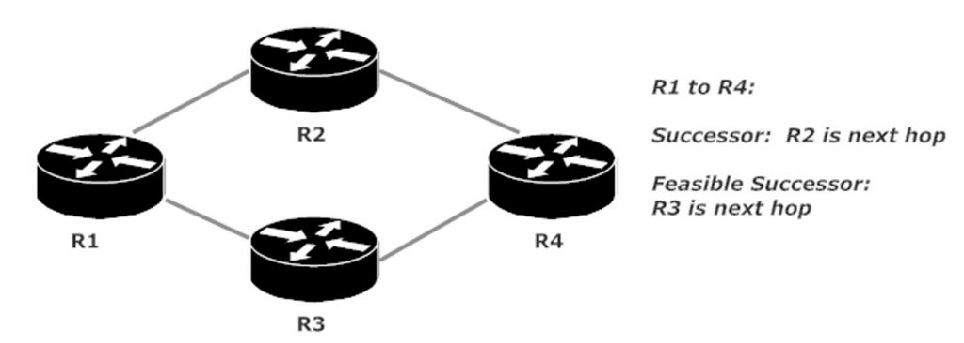
Should the primary route (the successor) be lost, EIGRP doesn’t need to calculate a new route. EIGRP would then name the route through R3 as the successor, and routing goes on.
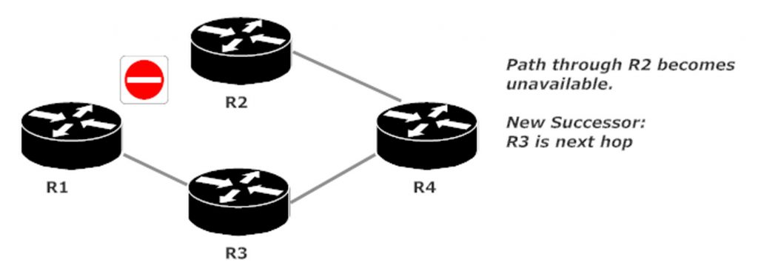
Let’s start our first lab right now by configuring and verifying EIGRP adjacencies on the following network! This is a hub-and-spoke network, with R1 serving as the hub and (you guessed it!) R2 and R3 serving as spokes. Any traffic that goes from R2 to R3, and vice versa, will pass through R1.
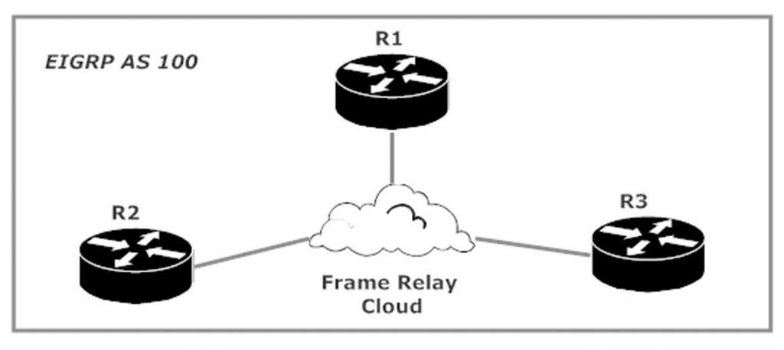
Each router’s Serial 0/1/0 interface is connected to the frame relay network, and we’re using the 172.12.123.0 /24 subnet for IP addressing. The router numbers are used for the 4th octet of the address – R1’s Serial 0/1/0 interface is 172.12.123.1, and so forth.
We’ll use the network command to enable EIGRP. The command network 172.12.123.0 0.0.0.255 enables EIGRP on any interface in the 172.12.123.0 /24 subnet. The use of wildcard masks is optional, but you’ll see them in 99% of real-world EIGRP deployments. Watch that detail on your CCNP ROUTE and TSHOOT exams. EIGRP and OSPF both use wildcard masks, but they’re required only in OSPF. The network 172.12.123.0 command is legal in EIGRP, as verified by IOS Help on R1.
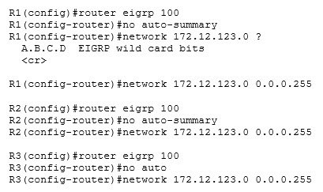
I disabled something called “auto-summary” on all three routers before I even put in the network command, so it must be important! More on this later, but for now note that EIGRP has autosummarization on by default.
Just a few seconds after enabling EIGRP on all three routers, this console message appeared on R1.
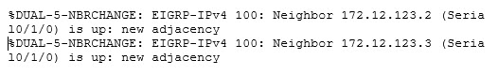
EIGRP hello packets have discovered two potential neighbors, and all must have been well, because those potential neighbors quickly became actual neighbors! We’ll verify with show ip eigrp neighbors.
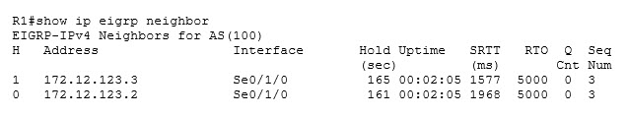
From left to right, the key values are the IP addresses of the EIGRP AS 100 neighbors, the local interface upon which they were discovered, and the uptime of the adjacency.
We have EIGRP adjacencies, but do we have any EIGRP routes? Let’s check via show ip route eigrp. (The code tables have been removed from the following command outputs for clarity’s sake.)
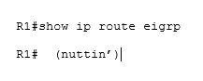
When a show command drops you right back at the enable prompt, that means there’s nothing to show you! We have no EIGRP routes because an address from the 172.12.123.0 /24 subnet is on a directly connected interface on each router.
Let’s get some EIGRP routes into our lab by adding a loopback to each router. We’ll use the router number for each octet in the address along with a /24 mask.
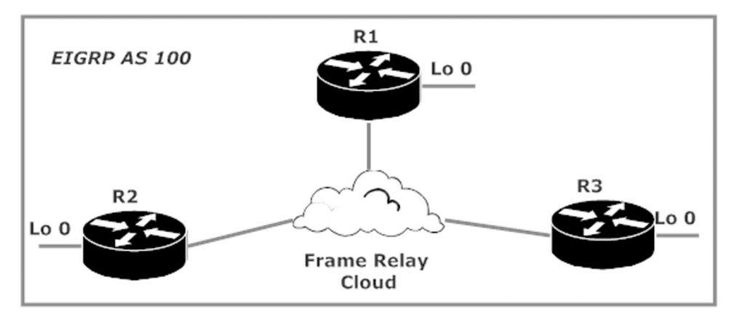
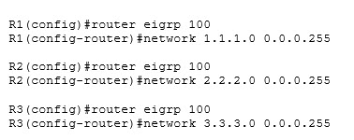
Let’s have a look at our EIGRP routing tables.
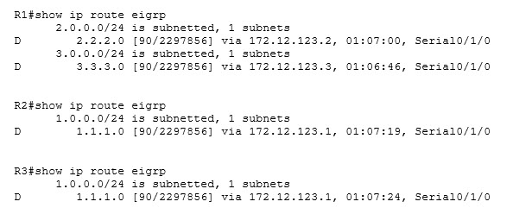

Curious! R1 is showing the EIGRP routes we’d expect, but neither spoke router can see the loopback network on the other spoke router. That’s due to split horizon, an important routing loop prevention behavior that can on occasion play havoc with your routing tables., especially when we have a hub-and-spoke network like this one.
There is no direct connection between our spoke routers, R2 and R3. Any traffic sent by one of those routers to the other must pass through the hub router (R1), and that’s where split horizon comes in. The rule of split horizon dictates that a router cannot advertise a route back out the same interface upon which it was originally learned. R1 is learning about R3’s loopback network via an EIGRP update received on Serial 0/1/0, so R1 can’t advertise that same network out that same interface. Therefore, R2 can’t learn about that network.
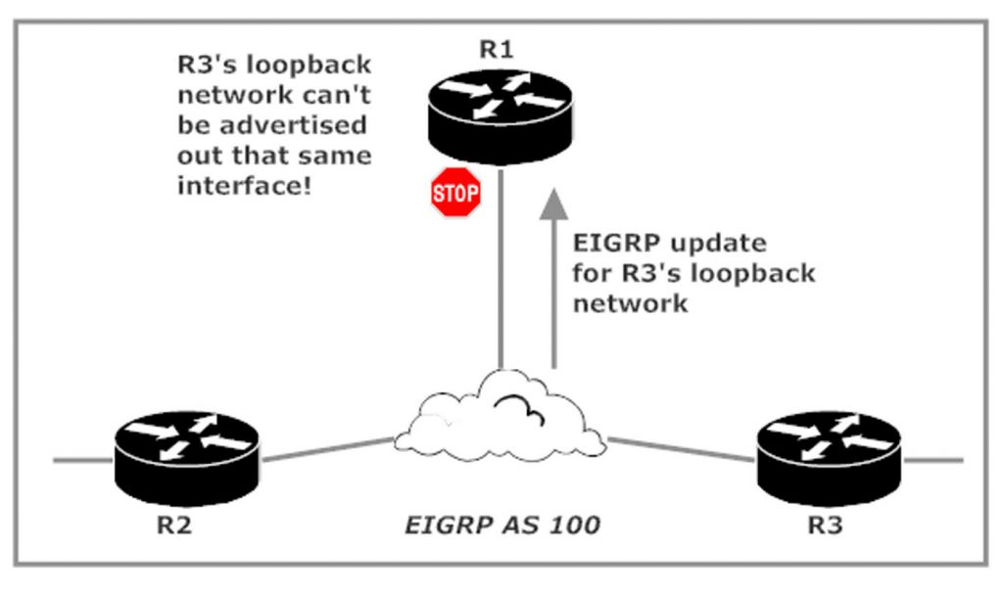
R1 is learning about R2’s loopback network via an update received on Serial 0/1/0 as well, so R1 can’t advertise that network via that same interface. R3 is left out in the cold!
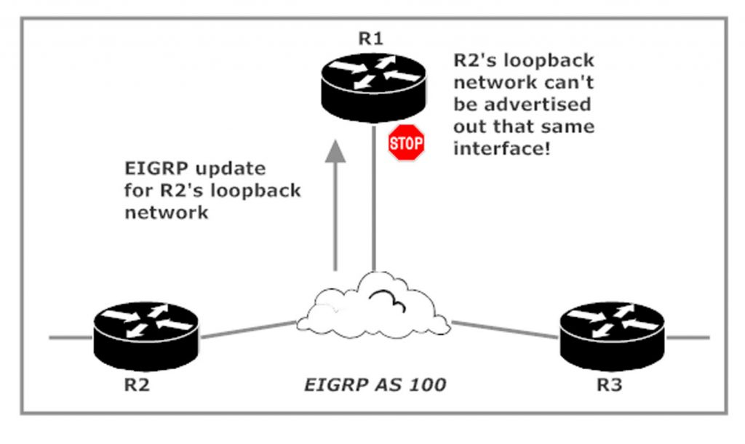
Split horizon can be disabled, and in a lab environment doing so doesn’t worry me (mostly). In a production network, I’d be very careful about doing so. While you may get the result you want, you might get other results that you don’t want!
Note that SH is disabled at the interface level and that the AS must be specified in this command. That’s pretty much the rule with EIGRP-related commands — you gotta tell the router what AS you’re working with (again).
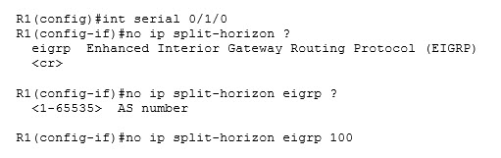
A few seconds later, I received these console messages:
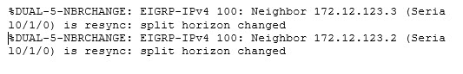In the past, disabling or enabling split horizon resulted in the temporary loss of EIGRP adjacencies. The messages here mention the neighbor being “resynced” instead of lost. The uptime from show ip eigrp neighbor verifies the adjacencies didn’t come all the way down. Had the adjacencies been lost, the uptime would show just a few seconds rather than over 100 minutes.
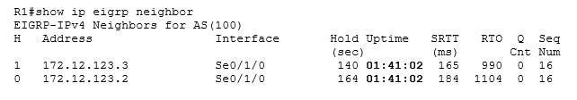
Disabling SH on the hub router’s Serial interface has the desired result, as R2 and R3 now see each other’s loopbacks. I’ve also pinged every interface from every router with 100% success (ping results not shown, you gotta trust me there), so we’re good to go!
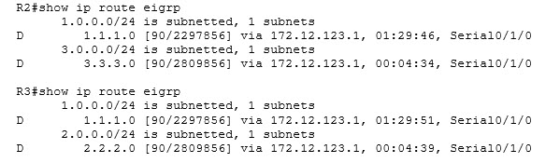
This is a great lab to get started, but to fully illustrate successor and feasible successor routes (along with other EIGRP features), we need a bigger network. We’ll start EIGRP Lab 2 by adding a broadcast segment to our network…
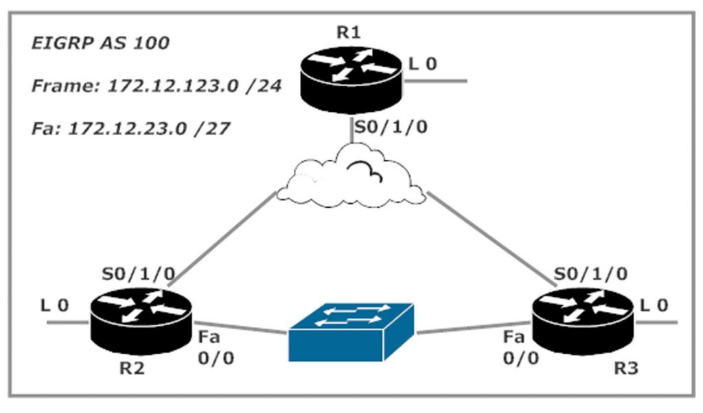
… and then we’ll see what kind of trouble we might just bump into! See you Wednesday, March 7 with the next lab!

Lab # 10

OBJECT

In this lab, you will learn how to configure OSPF and its Implementation

THEORY
Open Shortest Path First (OSPF):
The OSPF (Open Shortest Path First) protocol is one of a family of IP Routing protocols, and is
an Interior Gateway Protocol (IGP) for the Internet, used to distribute IP routing information
throughout a single Autonomous System (AS) in an IP network.
The OSPF protocol is a link-state routing protocol, which means that the routers exchange
topology information with their nearest neighbors. The topology information is flooded throughout
the AS, so that every router within the AS has a complete picture of the topology of the AS. This
picture is then used to calculate end-to-end paths through the AS, normally using a variant of the
Dijkstra algorithm. Therefore, in a link-state routing protocol, the next hop address to which data
is forwarded is determined by choosing the best end-to-end path to the eventual destination.
The following is a list of reasons OSPF is considered a better routing protocol than RIP:
 OSPF has no hop count limitations. (RIP has 15 hops only.)
 OSPF understands variable-length subnet masks (VLSMs) and allows for summarization.
 OSPF uses multicasts (not broadcasts) to send updates.
 OSPF converges much faster than RIP, because OSPF propagates changes immediately.
 OSPF allows for load balancing with up to six equal-cost paths.
 OSPF has authentication available. (RIPv2 does also, but RIPv1 does not.)
 OSPF allows for tagging of external routes injected by other autonomous systems.
 OSPF configuration, monitoring, and troubleshooting have a far greater IOS tool base than
RIP.
Procedure:
Step1:
Use the command router ospf process ID to start OSPF.
Step 2:
Use the network command to enable the interfaces.
Step 3:
Identify area assignments.

Topology:

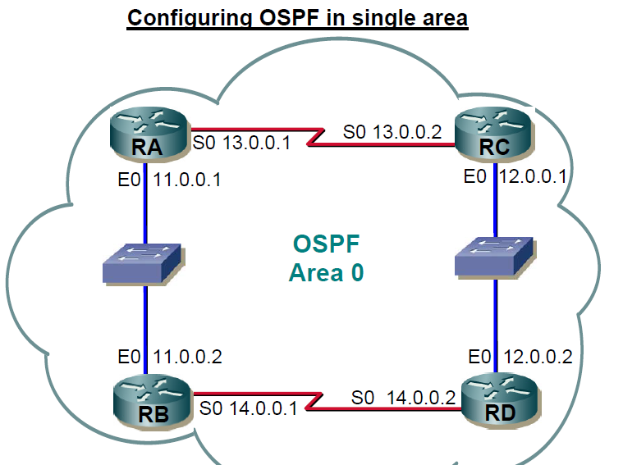

LAB TASK:

- Configure the routers
- Add the logging synchronous command to the console and virtual terminal lines
Router(config-line)#logging synchronous
- Disable DNS lookup
Router(config)#no ip domain-lookup
- Add the logging synchronous command to the console and virtual terminal lines
- Configure the interfaces on the R1, R2, and R3 routers with the IP addresses from the table under the Topology Diagram.
- Verify IP addressing and interfaces
show ip interface brief
- Configure Ethernet interfaces of PC1, PC2, and PC3
- Enable dynamic routing OSPF
- Use the show ip protocols command to view information about the routing processes

EXERCISES:

- What is OSPF what is the use of OSPF?

__________________________________________________________________
__________________________________________________________________

(2) Which OSPF version supports IPV6?

__________________________________________________________________

Lab # 11

OBJECT

In this lab, you will perform basic router configuration tasks.You will also learn how to configure Router on a Stick between different Networks.

THEORY

Router:

This device forwards data packets along networks. It is connected to at least two networks, commonly two LANs or WANs or a LAN and its ISP.s network. Routers are located at gateways, the places where two or more networks connect. Routers use headers and forwarding tables to determine the best path for forwarding the packets.

IP address:

Internet Protocol Address (or IP Address) is an unique address that computing devices such as personal computers, tablets, and smartphones use to identify itself and communicate with other devices in the IP network. Any device connected to

the IP network must have an unique IP address within the network. An IP address is analogous to a street address or telephone number in that it is used to uniquely identify an entity.

Subnetmask :

A subnet mask is a number that defines a range of IP addresses that can be used in a network . A subnet mask hides, or "masks," the network part of a system's IP address and leaves only the host part as the machine identifier.

MODES
The Cisco IOS is comprised of several modes, each of which contains a set of commands specific to the function of that mode.
Command Mode | Access Method | Prompt | Purpose | Exit Method
User Exec | Default mode after | Router> | Allow you to connect | Use exit command
 | booting. Login with |  | with remote devices,
 | password, if |  | perform basic tests,
 | configured. |  | temporary change terminal setting and list system information
Priveleged | Use enable | Router# | Allow you to set | Use exit command.
Exec | command from user |  | operating parameters.
 | exec mode |  | It also includes high level testing and list commands like show, copy and debug.
Cofiguration | Use configure | Router(config) | Contain commands | Use exit command
Mode | terminal command | # | those affect the entire
 | from privileged exec mode |  | system
Global | Use interface type | Router(config- | Contain commands | Use exit command to
/interface Configuration mode | number command from global configuration mode | if)# | those modify the operation of an interface | return in global configuration mode .
Sub interface | Use interface type | Router(config- | Configure or modify | Use exit to return in
Configuration | sub interface | subif)# | the virtual interface | previous mode. Use end
 | number command |  | created from physical | command to return in
 | from global configuration mode or interface configure mode. |  | interface | privileged exec mode.
ROMMON | Enter reload | ROMMON> | If router automatically | Use exit command.
 | command from |  | enter in this mode,
 | privileged exec |  | then it indicates that it
 | mode. Press CTRL |  | fails to locate a valid
 | + C key |  | IOS image. Manual
 | combination during |  | entrance in this mode
 | the first 60 seconds |  | Allow you to perform
 | of booting process |  | low-level diagnostics.

Topology:

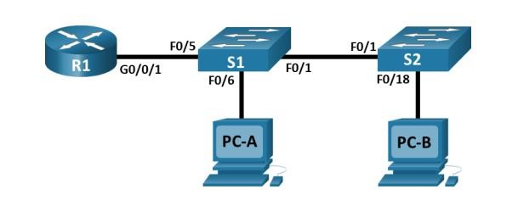

Address Table:

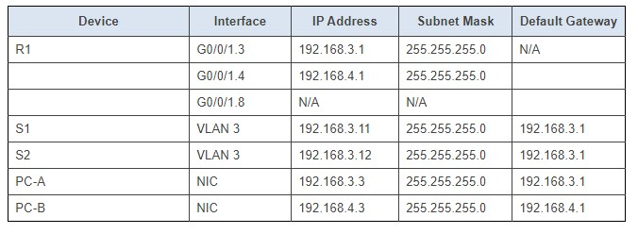

LAB TASK:

- Attach the devices as shown in the topology diagram, and cable as necessary.
- Configure basic settings for the router.
- Configure basic settings for each switch.
- Configure PC hosts.
- Verify and Test Network Connectivity by doing Ping from PC-A to its default gateway. Ping from PC-A to PC-B, Ping from PC-A to S2

EXERCISES:

- What happens if we connect PC directly to the router without using switch in between the two devices i.e. PC’s and router?

__________________________________________________________________ __________________________________________________________________

- What do you understand by the term Default-Gateway IP? Why we need to assign this?

__________________________________________________________________

- Explain the function of this command “Router(config-if)#”.

__________________________________________________________________
__________________________________________________________________ __________________________________________________________________

LAB objective:

Basic Needs for TCP/IP Communication
Some of the applications we use require us to move data across a network from point A to point B. The Transmission Control Protocol/Internet Protocol (TCP/IP) network provides a framework for transmitting this data, and it requires some basic information from us to move this data.
Introduction
In previous chapters, we learnt how VLANs segment broadcast traffic on a switch and segment a switched network into different LANs, we also learnt how VLAN information can be transmitted to other switches in the network using VTP and how we can avoid layer two loops using STP.
Consider, this, as the network administrator, one of your tasks is to create and assign different users to VLANs in your network, you have three main departments which should be logically segmented using VLANs, VLAN 10 – FINANCE, VLAN 20 – SALES and VLAN 30 – HR.
The use of VLANs means that users would not be able to communicate across departments, i.e. a user in FINANCE, would not be able to send a message to a user in SALES since they are on different broadcast domains.
In many enterprises, you will find that information sharing across departments is a requirement, therefore, the question begs, how do you make users in the SALES and FINANCE department communicate, yet they are on different VLANS?
In this chapter, we will discuss the role played by inter-VLAN routing in communication between different VLANs. We will learn how it works, consider the various methods that can be used to implement it, configure inter-VLAN routing using router-on-a-stick and traditional inter-VLAN routing, compare the two styles of implementation and finally verify and troubleshoot inter-VLAN routing.
Introduction to inter-vlan routing
When we learnt about VLANs, we said that each VLAN is usually on its own subnet, switches mainly operate at layer 2 of the OSI model and therefore they do not examine the logical addresses. Therefore, user nodes located on different VLANs cannot communicate by default. In many cases, we may need connectivity between users located on different VLANs. The way this can be accomplished is through inter-VLAN routing.
In this course, we will look at one type of inter-VLAN routing, which is through the use of a router.
Definition
Inter-VLAN routing can be defined as a way to forward traffic between different VLAN by implementing a router in the network. As we learnt previously, VLANs logically segment the switch into different subnets, when a router is connected to the switch, an administrator can configure the router to forward the traffic between the various VLANs configured on the switch. The user nodes in the VLANs forwards traffic to the router which then forwards the traffic to the destination network regardless of the VLAN configured on the switch.
The figure below, shows how this process works.

Information destined for PC B, leaves PC A with the VLAN 20 tag, when it gets to R1, the router, changes the format of this message from VLAN 20, to VLAN 30, it then sends it back to the switch and the switch finally sends the message to its intended recipient PC B.
There are two ways in which inter-VLAN routing can be accomplished.
- Traditional inter-VLAN routing
- Router-on-a-stick
Traditional inter-VLAN routing
In this type of inter-VLAN routing, a router is usually connected to the switch using multiple interfaces. One for each VLAN. The interfaces on the router are configured as the default gateways for the VLANs configured on the switch.
The ports that connect to the router from the switch are configured in access mode in their corresponding VLANs.
When a user node sends a message to a user connected to a different VLAN, the message moves from their node to the access port that connects to the router on their VLAN. When the router receives the packet, it examines the packet’s destination IP address and forwards it to the correct network using the access port for the destination VLAN. The switch now can forward the frame to the destination node since the router changed the VLAN information from the source VLAN to the destination VLAN.
In this form of inter-VLAN routing, the router has to have as many LAN interfaces as the number of VLANs configured on the switch. Therefore, if a switch has 10 VLANs, the router should have the same number of LAN interfaces.
Take the scenario shown below.

If PC A in VLAN 20, wanted to send a message to PC B in VLAN 30, the steps it would take are shown below.
- PC A would check whether the destination IPv4 address is in its VLAN if it is not, it would need to forward the traffic to its default gateway which is the ip address on Fa0/0 on R1.
- PC A then sends an ARP request to AS1 so as to determine the physical address of Fa0/0 on R1. Once the router replies, PC A can send the frame to the router as a unicast message, since AS1 has Fa0/0’s MAC address, it can forward the frame directly to R1.
- When the router receives the frame, it compares the destination IP address by referring to its routing table so as to know to which interface it should send the data towards the destination node.
- The router then sends an ARP request out the interface connected to the destination VLAN in this case out Fa0/1, when the switch receives the message, it would flood it to its ports and in this case, PC B would reply with its MAC address.
- R1 would then use this information to frame the packet and finally send it to PC B as a unicast frame.
Configuring traditional inter-VLAN routing
In this section, we will configure Inter-VLAN routing on the router and the switch using the scenario we have just seen above. All the VLANs are active and the PCs have been assigned ports, our configuration will only be limited to the router’s inter-VLAN configuration and the switch ports connecting to R1.

The ip addressing in use is shown below.

Testing connectivity using the ping command should reveal that PC A cannot ping PC B.
The first step is to configure the switchports to access the specified VLAN, fa0/1 to VLAN 20 and fa0/2 to VLAN 30. This is accomplished using the commands shown below.

This is the only configuration on the switch, once this is done save the configuration and move on to the router.
On R1, we need to configure its interfaces with the default gateways corresponding to the VLANs. That is; on fa0/0 -192.168.20.1/24 and on fa0/1 – 192.168.30.1/24. We accomplish this using the commands shown below.

With this configuration we should save and test for connectivity on PC A and PC B, by using the ping command, and the results should be successful. Examining the routing table of R1 should show us the two routes as shown in the output below. This confirms that the router knows of the two VLANs and therefore traffic can flow between them.

Inter-VLAN routing using router-on-a-stick
With the example shown above, there are several concerns, suppose we had 10 or even 20 VLANs configured on the switch, even if the switch has enough ports to support the connection to the router, it is highly unlikely that the router would have so many Ethernet interfaces. Therefore we need a way to use the limited router interfaces to support routing between many VLANs that may be on a switch.
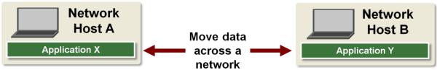
We need to specify if we want the most reliable or fastest transmissions and we need to specify where we want the data delivered. Sometimes our data is routed based on its IP addresses and sometimes it's routed based on its MAC address. The data we send needs both addressing capabilities. This information needs to be sent along with all transmitted data. We also need to physically transmit the data from one location to another.
Back to top
TCP/IP Five-Layer Software Model Overview
We need to provide this basic information needed by TCP/IP in a standard format the network can understand. This format is provided by its five-layer software model.
Each layer provides TCP/IP with the basic information it needs to move our data across the network. These layers group functions according to the task that needs to be performed. Every function in this model is targeted to help a specific layer perform its job.
Each layer only communicates with adjacent layers. Software running in a higher layer does not have to know about or perform tasks delegated to lower-layer functions and vice versa. For example, the software you write for your application only needs to know how to request a connection with a remote host using the Transport layer. It doesn’t need to know how bits are encoded before transmission. That’s the Physical layer’s job.
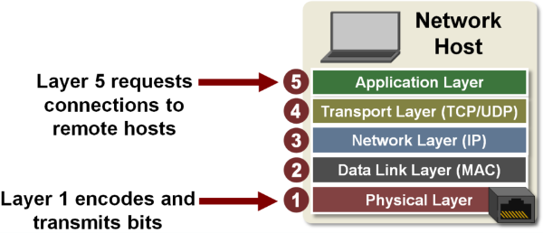
​You are probably familiar with the seven-layer OSI model. TCP/IP simplifies this model to five layers. OSI stands for Open Systems Interconnect, which is a standard communication systems model. The top four layers of the seven-layer OSI model have been condensed into the top two TCP/IP layers.
Back to top
TCP/IP Five-Layer Model
Application Layer (Layer 5)
As you might have guessed, the Application layer is where applications requiring network communications live. Examples of these applications include email clients (SMTP) and web browsers (HTTP). These applications use the Transport Layer to send requests to connect to remote hosts.
Common TCP/IP applications >
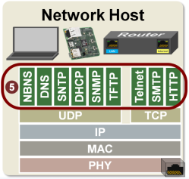
Back to top
Transport Layer (Layer 4)
Layer 4 is the Transport layer. The transport layer creates virtual Transfer Control Protocol (TCP) or User Datagram Protocol (UDP) connections between network hosts.
This layer sends and receives data (packets) to and from the applications running on its host. The Transport layer assigns port numbers to the processes running in applications on the host and adds a TCP or UDP header to the messages received from the applications detailing the source and destination port numbers.
Note that some of the applications, specifically Telnet, SMTP, and HTTP require TCP as the transport protocol while others use UDP.
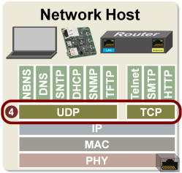
Some applications require reliable ordered delivery of packets. The TCP protocol provides this capability. It uses error detection, retransmissions and acknowledgments. This protocol cares about your data.
Other applications don’t care if every packet is received. These applications can take advantage of UDP’s lower overhead to enable faster transmissions.
Typical TCP applications include email and web browsing and typical UDP applications include VoIP and music streaming.
TCP is strictly used for point-to-point or unicast transmissions while UDP can also be used for multicast and broadcast transmissions.
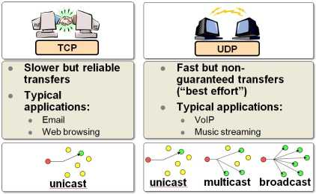
For more information on TCP, visit the "Transmission Control Protocol" page.
For more information on UDP, visit the "User Datagram Protocol" page
Back to top
TCP and UDP Headers
The header added to messages by the Transport layer includes more than just the source and destination port numbers. Here we are showing all the information included in TCP and UDP headers.
Note how the TCP protocol requires more information and overhead to guarantee data delivery.
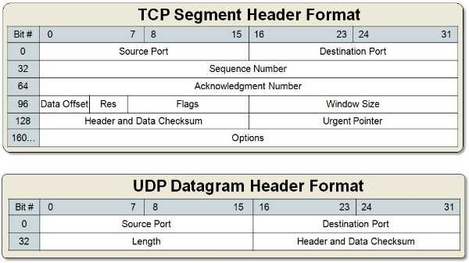
Back to top
Network Layer (Layer 3)
Layer 3 is the Network or Internet layer.
When transmitting data (packets), this layer adds a header containing the source and destination IP addresses to the data received from the Transport layer. The packet it creates will then be forwarded to the MAC or Data Link layer.
When receiving data, this layer is used to determine if the packet received by the host contains the host’s IP address. If it does, the data is forwarded up to the Transport layer.
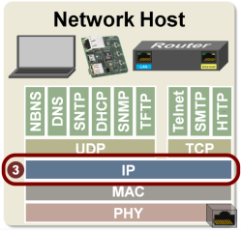
​Routers are referred to as “layer 3” devices because they route packets based on their IP addresses.
Back to top
TCP/IP IPv4 Packet Header
The Network layer header includes more than just the source and destination IP addresses.
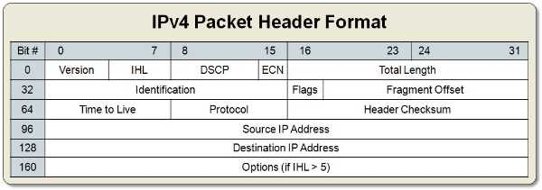
Back to top
Data Link Layer (Layer 2)
Layer 2 is the Data Link layer. This layer uses a Media Access Controller (MAC) to generate the frames that will be transmitted. As the name suggests, the MAC controls the physical transmission media. The wireless transmission media used for Wi-Fi® or 802.11 has different requirements from the wired transmission media used for Ethernet or 802.3, and therefore needs a different MAC and PHY. Note the upper layer software is not aware of or affected by the physical interface.
When transmitting data, this layer adds a header containing the source and destination MAC addresses to the packet received from the Network layer (layer 3). The frame it creates will then be forwarded to the Physical layer.
When receiving data, this layer is used to determine if the frame received by the host contains the host’s MAC address. If it does, the data is forwarded up to the Network layer.
Every host on the network has at least one MAC address. Laptops typically have two, one for the wired LAN and one for the wireless LAN. Home routers also typically have two MACs: one for the local network and one for the Internet.
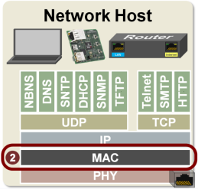
​Most switches are referred to as “layer 2” devices because they route frames based on their MAC addresses.
Back to top
Ethernet and Wi-Fi® Frame Format
As you probably guessed, the Data Link layer adds more than just the source and destination MAC addresses to the packet. Note that the MAC for Ethernet and Wi-Fi are different and generate different frames.
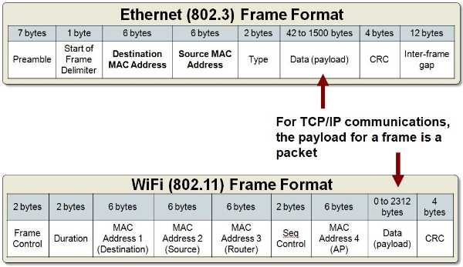
LAB TASK
1: Filter out the TCP three-way handshaking packets out from your windump data and explain it as the same style as in the webpage
2: Draw the time sequence diagram for the TCP three way handshaking

Lab 13

Introduction to cyber security
Network security lab's
- configure password and SHH
- Identify packet.

cyber security
Cyber security is the practice of defending computers, servers, mobile devices, electronic systems, networks, and data from malicious attacks. It's also known as information technology security or electronic information security. The term applies in a variety of contexts, from business to mobile computing, and can be divided into a few common categories.

Types of cyber threats
The threats countered by cyber-security are three-fold:
1. Cybercrime includes single actors or groups targeting systems for financial gain or to cause disruption.
2. Cyber-attack often involves politically motivated information gathering.
3. Cyberterrorism is intended to undermine electronic systems to cause panic or fear.
So, how do malicious actors gain control of computer systems? Here are some common methods used to threaten cyber-security:

Malware
Malware means malicious software. One of the most common cyber threats, malware is software that a cybercriminal or hacker has created to disrupt or damage a legitimate user’s computer. Often spread via an unsolicited email attachment or legitimate-looking download, malware may be used by cybercriminals to make money or in politically motivated cyber-attacks.
There are a number of different types of malware, including:
• Virus: A self-replicating program that attaches itself to clean file and spreads throughout a computer system, infecting files with malicious code.
• Trojans: A type of malware that is disguised as legitimate software. Cybercriminals trick users into uploading Trojans onto their computer where they cause damage or collect data.
• Spyware: A program that secretly records what a user does, so that cybercriminals can make use of this information. For example, spyware could capture credit card details.
• Ransomware: Malware which locks down a user’s files and data, with the threat of erasing it unless a ransom is paid.
• Adware: Advertising software which can be used to spread malware.
• Botnets: Networks of malware infected computers which cybercriminals use to perform tasks online without the user’s permission.

SQL injection
An SQL (structured language query) injection is a type of cyber-attack used to take control of and steal data from a database. Cybercriminals exploit vulnerabilities in data-driven applications to insert malicious code into a databased via a malicious SQL statement. This gives them access to the sensitive information contained in the database.

Phishing
Phishing is when cybercriminals target victims with emails that appear to be from a legitimate company asking for sensitive information. Phishing attacks are often used to dupe people into handing over credit card data and other personal information.

Man-in-the-middle attack
A man-in-the-middle attack is a type of cyber threat where a cybercriminal intercepts communication between two individuals in order to steal data. For example, on an unsecure WiFi network, an attacker could intercept data being passed from the victim’s device and the network.

Denial-of-service attack
A denial-of-service attack is where cybercriminals prevent a computer system from fulfilling legitimate requests by overwhelming the networks and servers with traffic. This renders the system unusable, preventing an organization from carrying out vital functions.

Latest cyber threats
What are the latest cyber threats that individuals and organizations need to guard against? Here are some of the most recent cyber threats that the U.K., U.S., and Australian governments have reported on.

Dridex malware
In December 2019, the U.S. Department of Justice (DoJ) charged the leader of an organized cyber-criminal group for their part in a global Dridex malware attack. This malicious campaign affected the public, government, infrastructure and business worldwide.
Dridex is a financial trojan with a range of capabilities. Affecting victims since 2014, it infects computers though phishing emails or existing malware. Capable of stealing passwords, banking details and personal data which can be used in fraudulent transactions, it has caused massive financial losses amounting to hundreds of millions.
In response to the Dridex attacks, the U.K.’s National Cyber Security Centre advises the public to “ensure devices are patched, anti-virus is turned on and up to date and files are backed up”.

Romance scams
In February 2020, the FBI warned U.S. citizens to be aware of confidence fraud that cybercriminals commit using dating sites, chat rooms and apps. Perpetrators take advantage of people seeking new partners, duping victims into giving away personal data.
The FBI reports that romance cyber threats affected 114 victims in New Mexico in 2019, with financial losses amounting to $1.6 million.

Emotet malware
In late 2019, The Australian Cyber Security Centre warned national organizations about a widespread global cyber threat from Emotet malware.
Emotet is a sophisticated trojan that can steal data and also load other malware. Emotet thrives on unsophisticated password: a reminder of the importance of creating a secure password to guard against cyber threats.

End-user protection
End-user protection or endpoint security is a crucial aspect of cyber security. After all, it is often an individual (the end-user) who accidentally uploads malware or another form of cyber threat to their desktop, laptop or mobile device.
So, how do cyber-security measures protect end users and systems? First, cyber-security relies on cryptographic protocols to encrypt emails, files, and other critical data. This not only protects information in transit, but also guards against loss or theft.
In addition, end-user security software scans computers for pieces of malicious code, quarantines this code, and then removes it from the machine. Security programs can even detect and remove malicious code hidden in primary boot record and are designed to encrypt or wipe data from computer’s hard drive.
Electronic security protocols also focus on real-time malware detection. Many use heuristic and behavioral analysis to monitor the behavior of a program and its code to defend against viruses or Trojans that change their shape with each execution (polymorphic and metamorphic malware). Security programs can confine potentially malicious programs to a virtual bubble separate from a user's network to analyze their behavior and learn how to better detect new infections.
Security programs continue to evolve new defenses as cyber-security professionals identify new threats and new ways to combat them. To make the most of end-user security software, employees need to be educated about how to use it. Crucially, keeping it running and updating it frequently ensures that it can protect users against the latest cyber threats.

Cyber safety tips - protect yourself against cyberattacks
How can businesses and individuals guard against cyber threats? Here are our top cyber safety tips:
1. Update your software and operating system: This means you benefit from the latest security patches.
2. Use anti-virus software: Security solutions like Kaspersky Total Security will detect and removes threats. Keep your software updated for the best level of protection.
3. Use strong passwords: Ensure your passwords are not easily guessable.
4. Do not open email attachments from unknown senders: These could be infected with malware.
5. Do not click on links in emails from unknown senders or unfamiliar websites:This is a common way that malware is spread.
6. Avoid using unsecure WiFi networks in public places: Unsecure networks leave you vulnerable to man-in-the-middle attacks.

SSH Configuration on Packet Tracer
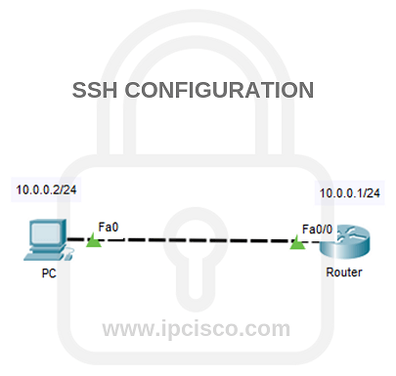

SSH Config
SSH (Secure Shell) is one of the most used protocols in network World. As a secured alternative of Telnet, SSH is always in the life of a network engineer. It helps us to connect our routers, swithces and any other network equipments. Especially because of SSH is more secure, it is always prefered more than Telnet. In this lesson, we will focus on SSH Configuration on Cisco routers with an SSH Config Example. We will learn configuring SSH.

o, what will be our SSH Config steps? In this example, we will go through the below six steps one by one:
- IP Configurations
- Password Encryption
- Router Name Change
- Domain Data and Data Encryption
- Router User Config
- SSH Config
- SSH Verification

Domain Name and Data Encryption
In this step, we will set the domain name. Our domain name will be SSHabc. And after that, we will encrypt the data in it with “crypto key generate rsa” command.

During this configuration we will set the module sizes. So we will use 512 here.

ABC (config) # ip domain-name SSHabc
ABC (config)# crypto key generate rsa general-keys modules 512
Lastly, we will save our SSH Configuration.

ABC (config) # line vty 0 15
ABC (config-line) # transport input ssh
ABC (config-line) # login local
ABC (config-line) # ip ssh version 2
ABC (config-line) # end
ABC # write

